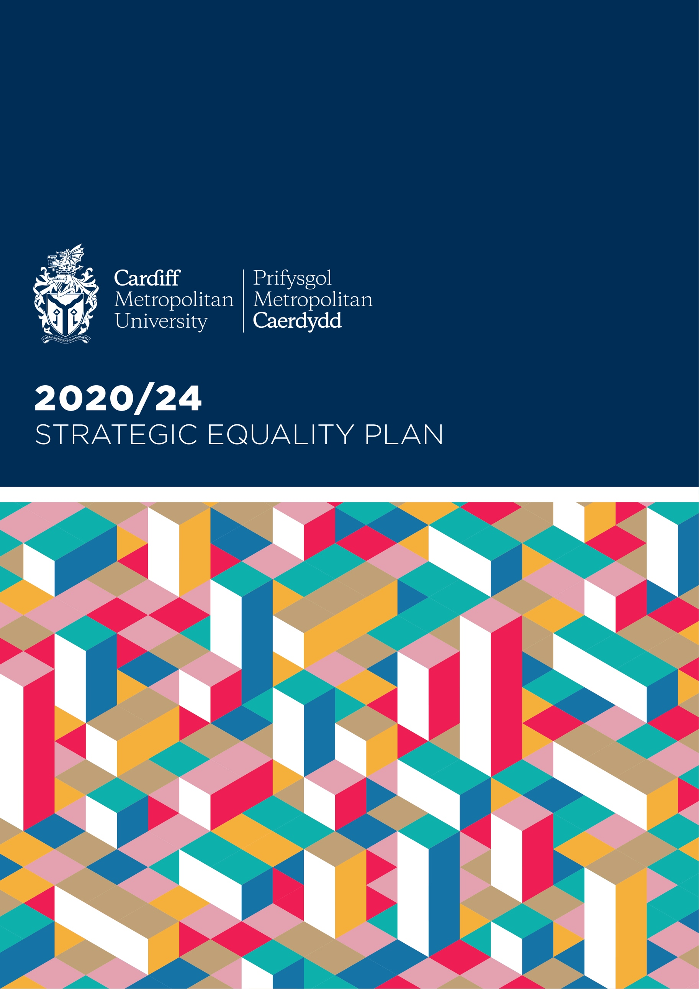



Contents

Cardiff Metropolitan University Strategic Vision 3
Summary and review of the Strategic Equality Plan 4
Our Equality Objectives 5
Monitoring Progress and Delivery 15
Strategic Equality Plan 2020-24 Outcomes 15
Strategic Equality Plan 2020-24 Consultation 16
Equality Legislation 16
Strategic Equality Plan 16
General Duty 16
Specific Duties 17
Welsh Language 17
The Well-being of Future Generations (Wales) Act 2015 18
Identifying and Collecting Relevant Equality Information 18
Publishing Employment Information 19
Arrangements for Equality Impact Assessments (EIA) 19
Promoting Knowledge and Understanding 20

Cardiff Metropolitan University Strategic Vision

Cardiff Metropolitan is a thriving global university founded in 1865 with a rich and established history, based in a vibrant European capital city. With an academic portfolio oriented towards practice-focused and professionally recognised education and research, the University offers over 250 taught programmes with a strong focus on employability and teaching excellence. We are committed to ensuring that every student fulfils their potential to make outstanding graduate-level contributions to their own and future generations.

Cardiff Metropolitan University has around 10,000 students on two campuses in Cardiff where student numbers have grown steadily over the last three years. The University has a further 9,000 trans-national education students studying Cardiff Met degrees at 16 partner institutions around the world.

Our Corporate Strategic Plan 2017/18 – 2022/23 signalled a 'step change' for the University by outlining a programme of seven priorities, one of which is the establishment of a values-driven University that champions creativity, diversity, freedom and innovation to generate educational transformation, research with impact, sustainable economic growth, social cohesion and health and wellbeing. The delivery of this plan is supported by the three pillars of Places, People and Performance:

Places where staff, students and stakeholders come together to devise and deliver transformational education, research and innovation in partnership.

People who create the high quality and high impact education, research and innovation that will establish Cardiff Met as a top 50 UK university.

Performance that we expect of our people and which is underpinned by our shared values and evidenced by our behaviours.

Through the alignment of our overarching Corporate Strategy with the Strategic Equality Plan 2020-2024 we will aspire to improve Cardiff Met’s equality and diversity profile, signalling our long-term commitment to champion equality of opportunity and promote effective and inclusive practice in Higher Education.

Summary and review of the Strategic Equality Plan

The current Strategic Equality Plan 2020-24 sets out the approach taken by Cardiff Metropolitan University to advance and support equality, diversity and inclusion, working beyond our legislative requirements. As an employer and Higher Education provider, Cardiff Metropolitan University can play a key role in Wales, implementing and influencing positive change through the promotion of equality of opportunity within the sector and our community. The Plan sets out our intended direction of travel over the next four years, mapping closely to our corporate ambitions.

Progress has been made throughout the University following the implementation of our last two Strategic Equality Plans. One of the mains lessons that was learned was during the development of our 2016-20 Plan, whereby in some areas of the organisation, our approach was characterised as ‘fixing the people for the University’ rather than ‘fixing the University for the people’. In other words, we tended to favour helping individuals overcome the way in which the University operates rather than seeking to make fundamental changes to the way in which the University is designed and operates. This lesson has been vital in shaping the ongoing development of the University, ensuring that Equality, Diversity and Inclusion is embedded in everything that we do.

There have been a number of notable achievements during the implementation of our 2016-20 Strategic Equality Plan. Achievements include:

- Establishment of Women’s, Disabled and BME Staff Networks
- Creation of a staff and student Interfaith working Group
- Three successful Athena SWAN Bronze Departmental awards
- Successful Institutional Athena SWAN Bronze renewal in March 2020
- Publication of Gender Pay Gap information and associated action plans
- Revised Equality in the Workplace Training
- Implementation of Unconscious Bias training
- Introduction of Trans Awareness Training
- Revised HR Policies (Maternity, Paternity, Parental Leave Policies and benefits)
- Creation of Equality and Diversity Business Intelligence Dashboard
- Establishment of Women to Reader/Professor scheme
- Sponsorship and support of Black History Month Wales
- University signatory of Time To Change Wales pledge
- Introduction of Gender Neutral Toilet Facilities
- Successful self-assessment to become Disability Confident ‘Employer’
- Establishment of Changing the Culture Group
- Revision of Equality Impact Assessment Form and Guidance

The current Plan has been developed following a review of our previous 2016-2020 SEP and with considered alignment with the University’s overarching Corporate Strategy and existing school and professional services strategies. The review established that some of previously identified themes and objectives identified in our 2016-20 plan can be carried forward into the new 2020-2024 Plan. Furthermore, additional themes, objectives and actions have also been identified, reflecting the changing climate within Higher Education and the ever greater need to continue to advance equality of opportunity.

Feedback received from evaluation tools such as Disability Confident, Stonewall Workplace Equality Index and Athena Swan amongst others, has played a key role in the identification of gaps in our existing provision, while also highlighting examples of best practice across the University.

As a cross-cutting strategic agenda this Plan is relevant to every student, internal and external stakeholder and staff member of the University. We acknowledge that this plan is an evolving document and we will review it to ensure it remains fit for purpose.

Our Equality Objectives

In the development of this plan and its associated objectives and priorities, Cardiff Met has taken account of the Welsh Government’s draft Strategic Equality Plan short and long-term aims and objectives. Furthermore, the development of our objectives and priorities have been informed through collaboration with other Higher Education and Public Sector bodies to ensure an integrated and coordinated approach to drive equality forward and challenge the inequalities that persist across the Public Sector and Higher Education in Wales.

Our equality objectives embody Cardiff Met’s commitment, not just for the next four years, but our long-term vision to support the advancement of equality, diversity and inclusion, ensuring we work beyond our legislative responsibility, embedding equality of opportunity in everything we do.

A variety of other sources have been used to gather the information needed to produce this plan and the equality objectives. These include:
- “Is Wales Fairer?” 2018 Report;
- Cardiff Metropolitan University Strategic Corporate Plan and other associated internal Strategies;
- Cardiff Metropolitan University Vice-Chancellors Executive Group
- Institutional equalities data relating to staff and students;
- Draft equality objectives of the Welsh Government;
- Advance HE Welsh EDI Group Meetings
- EHRC and Welsh Government PSED symposium
- EHRC Briefing – The Public Sector Equality Duty and Higher Education in Wales
- Consultation with Equality and Human Rights Commission Wales;
- The Equality and Human Rights Commission (EHRC) report of its inquiry into racial harassment at higher education institutions;
- UUK Tackling sexual misconduct and gender-based violence, harassment and hate crime: Two Years On report;
- HEFCW Circulars

This information collated has shaped the action that will be taken to achieve Cardiff Met’s equality objectives between 2020 and 2024.

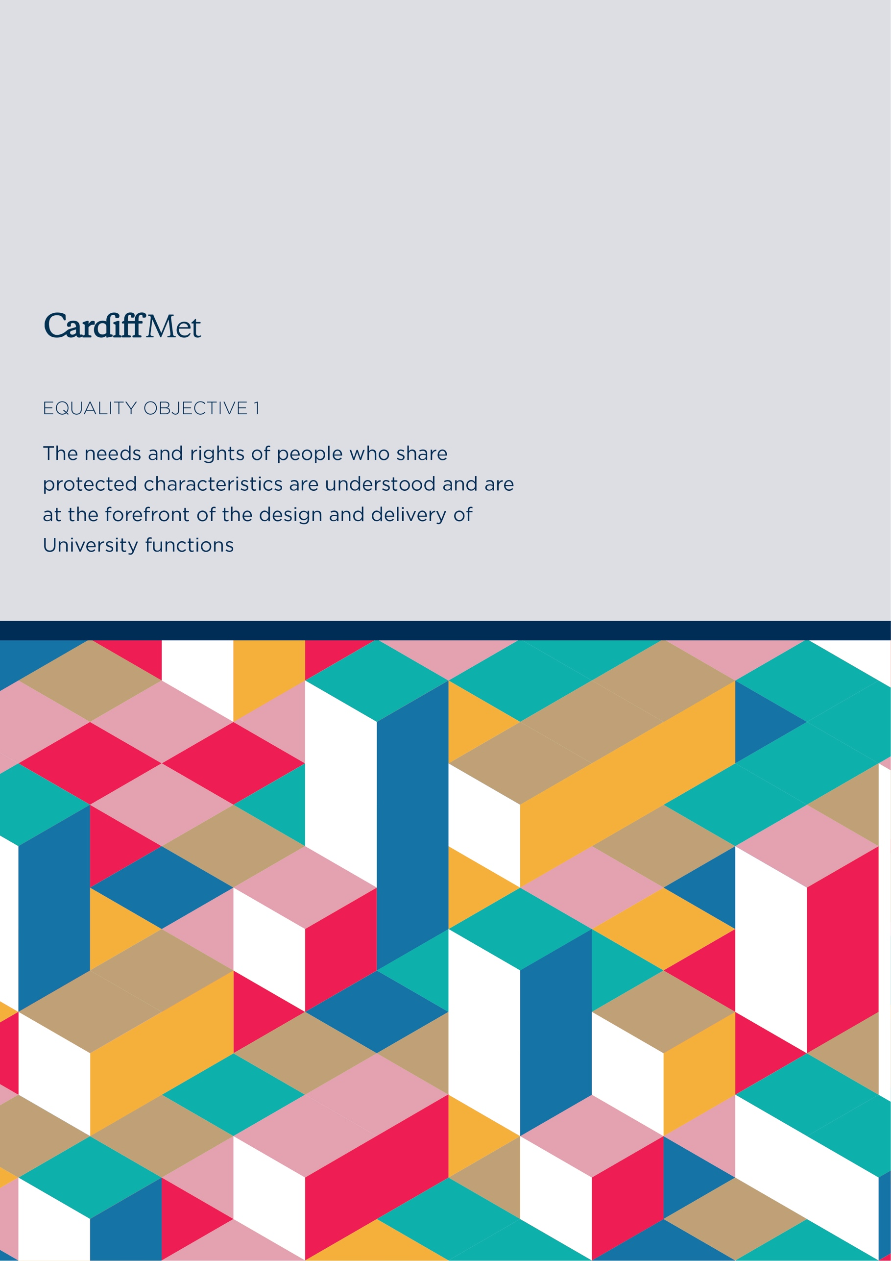

Equality Objective 1:
The needs and rights of people who share protected characteristics are understood and are at the forefront of the design and delivery of University functions
The University recognises that individual’s outcomes are not restricted to singular characteristics and will respond to the challenges presented by the intersectional identities of the members of our community.
Priorities

We will:
- Take all practical steps to ensure that the campus is accessible and inclusive for all, recognising accessibility in its broadest definition and not simply as physical access.

- Review the curriculum to ensure that it is inclusive in content and form of delivery

- Work to secure action on addressing student retention and outcome gaps between those who share protected characteristics and those who do not, ensuring accurate data that enables analysis

- Review existing processes and procedures in place to ensure robust data collection and monitoring of Equality Data

- Work with local diverse communities to build better relationships with people and organisations that can promote the University as an employer, educator and service

- Engage with our staff and students to encourage participation and to have their voices heard when planning service delivery

- To engage with staff from under-represented groups with the aim of identifying any potential or perceived barriers to progression within the University

- Place Welsh language at the heart of our community, actively promoting the development of the language and our activities and services available through the medium of Welsh

- Continue to promote, implement and develop Widening participation to raise educational aspirations and skills, promote higher education-level study, attracting people who otherwise would not contemplate higher education

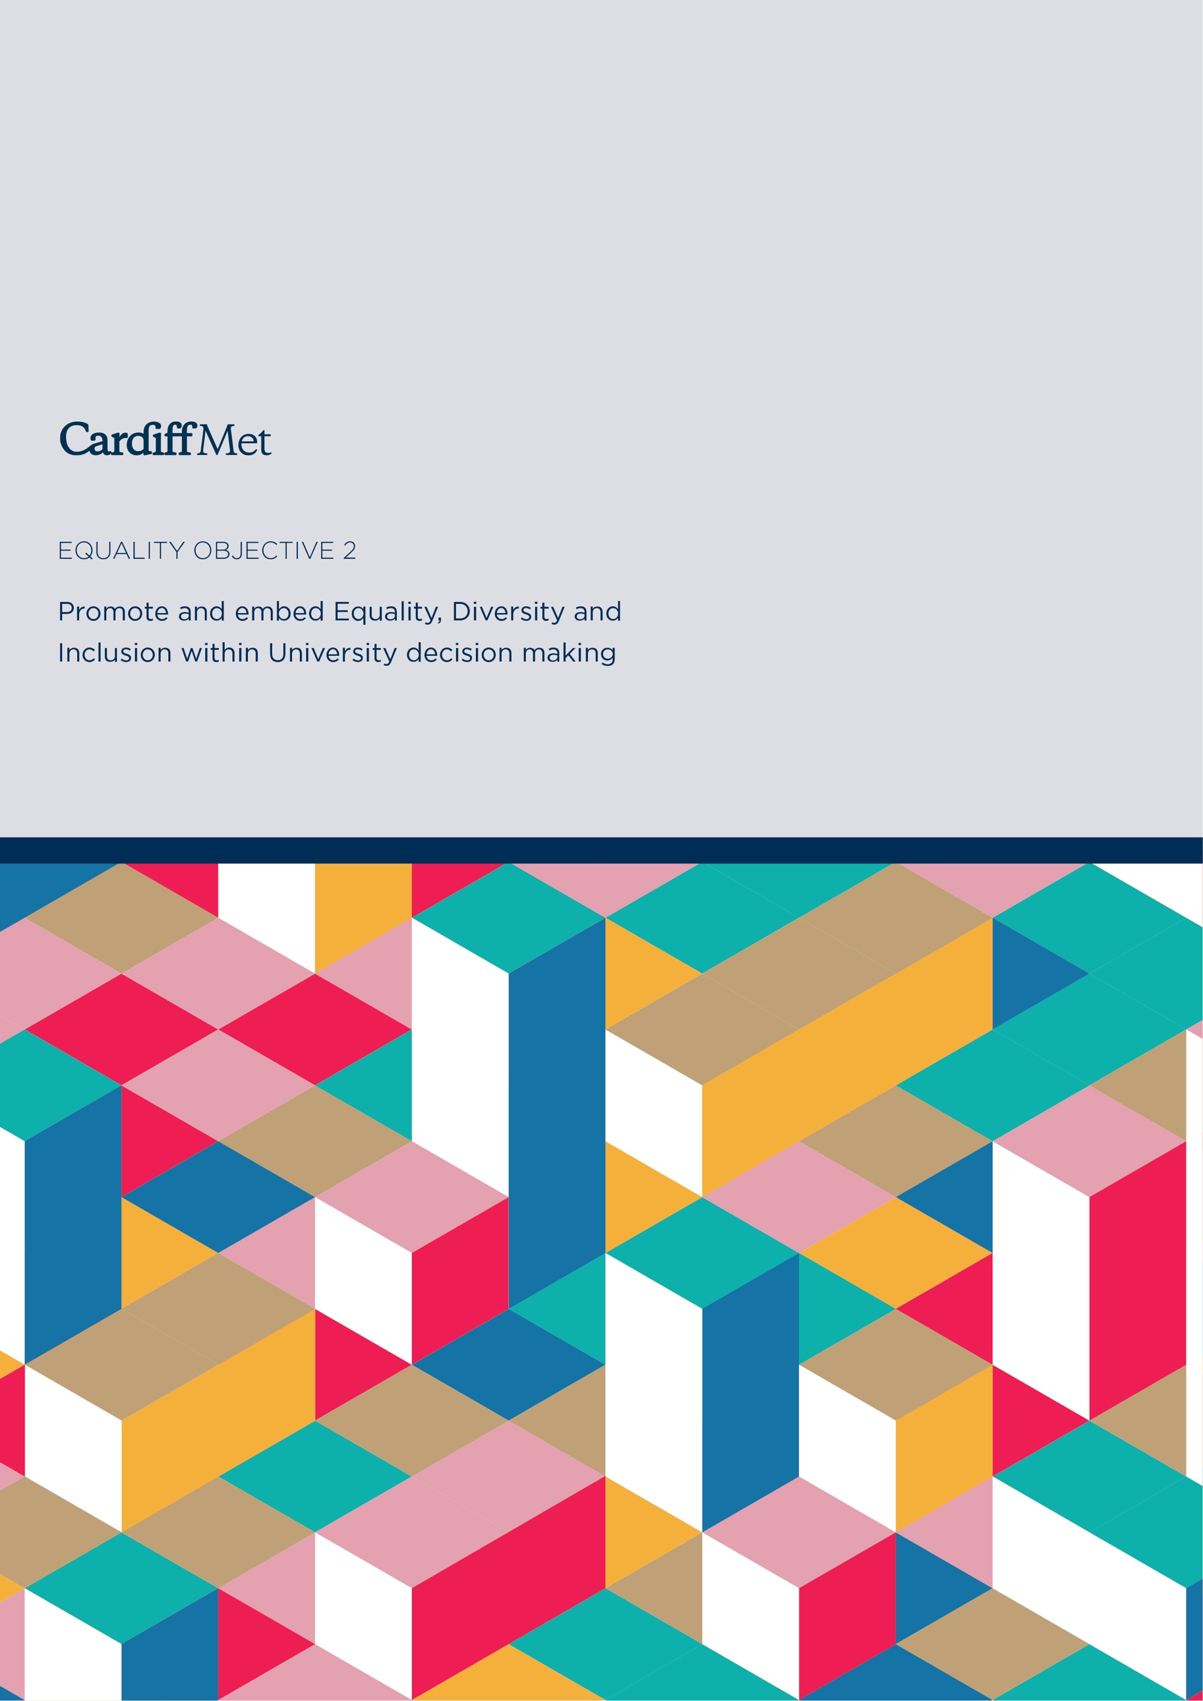

Equality Objective 2:
Promote and embed Equality, Diversity and Inclusion within University decision making
The University will continue to mainstream proactively, equality and diversity into all areas of decision making, management and leadership development, committee representation and policy review.

Priorities

We will:
- Continue to promote our commitment to Equality, Diversity and Inclusion throughout the procurement process and in our relationships with suppliers and contractors

- Review our current stakeholder list to ensure an appropriate level of representation of groups from each of the protected characteristics

- Continue to embed and mainstream Equality Impact Assessments (EIAs) in University business, including socio-economic considerations

- Promote local leadership of equality promotion within Schools and Professional Services

- Continue to advocate Cardiff Metropolitan University as a values-driven Global University

- Ensure Equality and Diversity Delivery Group has oversight of Strategic Equality Plan to enable the committee to be actively engaged and consulted on policy and strategy development, and to be advised on progress against meeting actions

- Work closely with Students’ Union Trade Union representatives around the introduction and revision of policies and procedures ensuring that equality, diversity and inclusion are always given the appropriate consideration

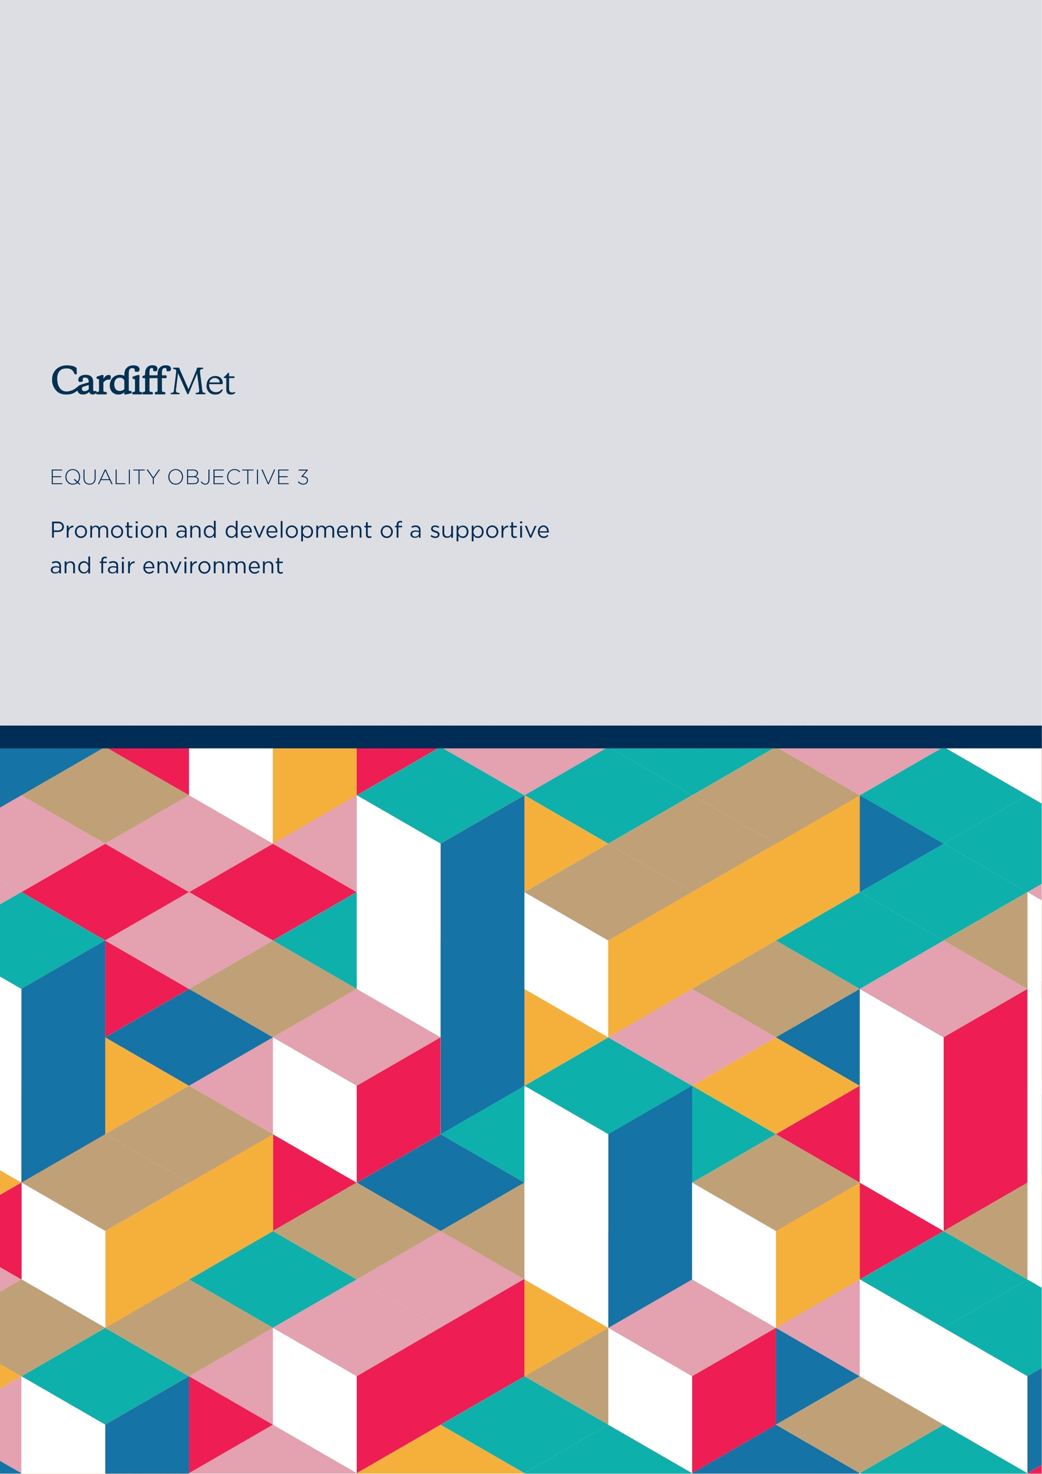

Equality Objective 3:
Promotion and development of a supportive and fair environment

We will maintain and continue to develop a culture where people are feeling safe, accepted and wanted in the culture that they bring, building relations across cultural, faith, ethnic and other divides.

The following priorities will help provide a platform to build on to help in the promotion and development of a safe University community.
Priorities

We will:

- Actively work to promote, develop and share best practice in the elimination of identity-based abuse, harassment, hate-crime and bullying

- Establish of University Race Equality Charter Task and Finish Group to review and implement the recommendations in the Equality and Human Rights Commission’s report: Tackling Racial Harassment: Universities Challenged

- Through the University Changing The Culture Group, take a cross University approach, working beyond the legislative requirements and guidance produced under the Violence against Women, Domestic Abuse and Sexual Violence (Wales) Act 2015

- Develop a package of resources that help staff and students to focus on their physical, psychological and digital well-being

- Promote a culturally cohesive community, bringing people together, physically or virtually, to promote tolerance and understanding and a sense of belonging for all communities

- Continue to support Wales’ ‘Nation of Sanctuary’ commitments, increasing opportunities for refugees and asylum seekers to access higher education

- Actively promote Ethical Supply Chains, ensuring a collective approach to Procurement

- Strengthen collection and analysis of data for formal and informal staff and student complaints

- Produce and implement a new University Safeguarding Policy

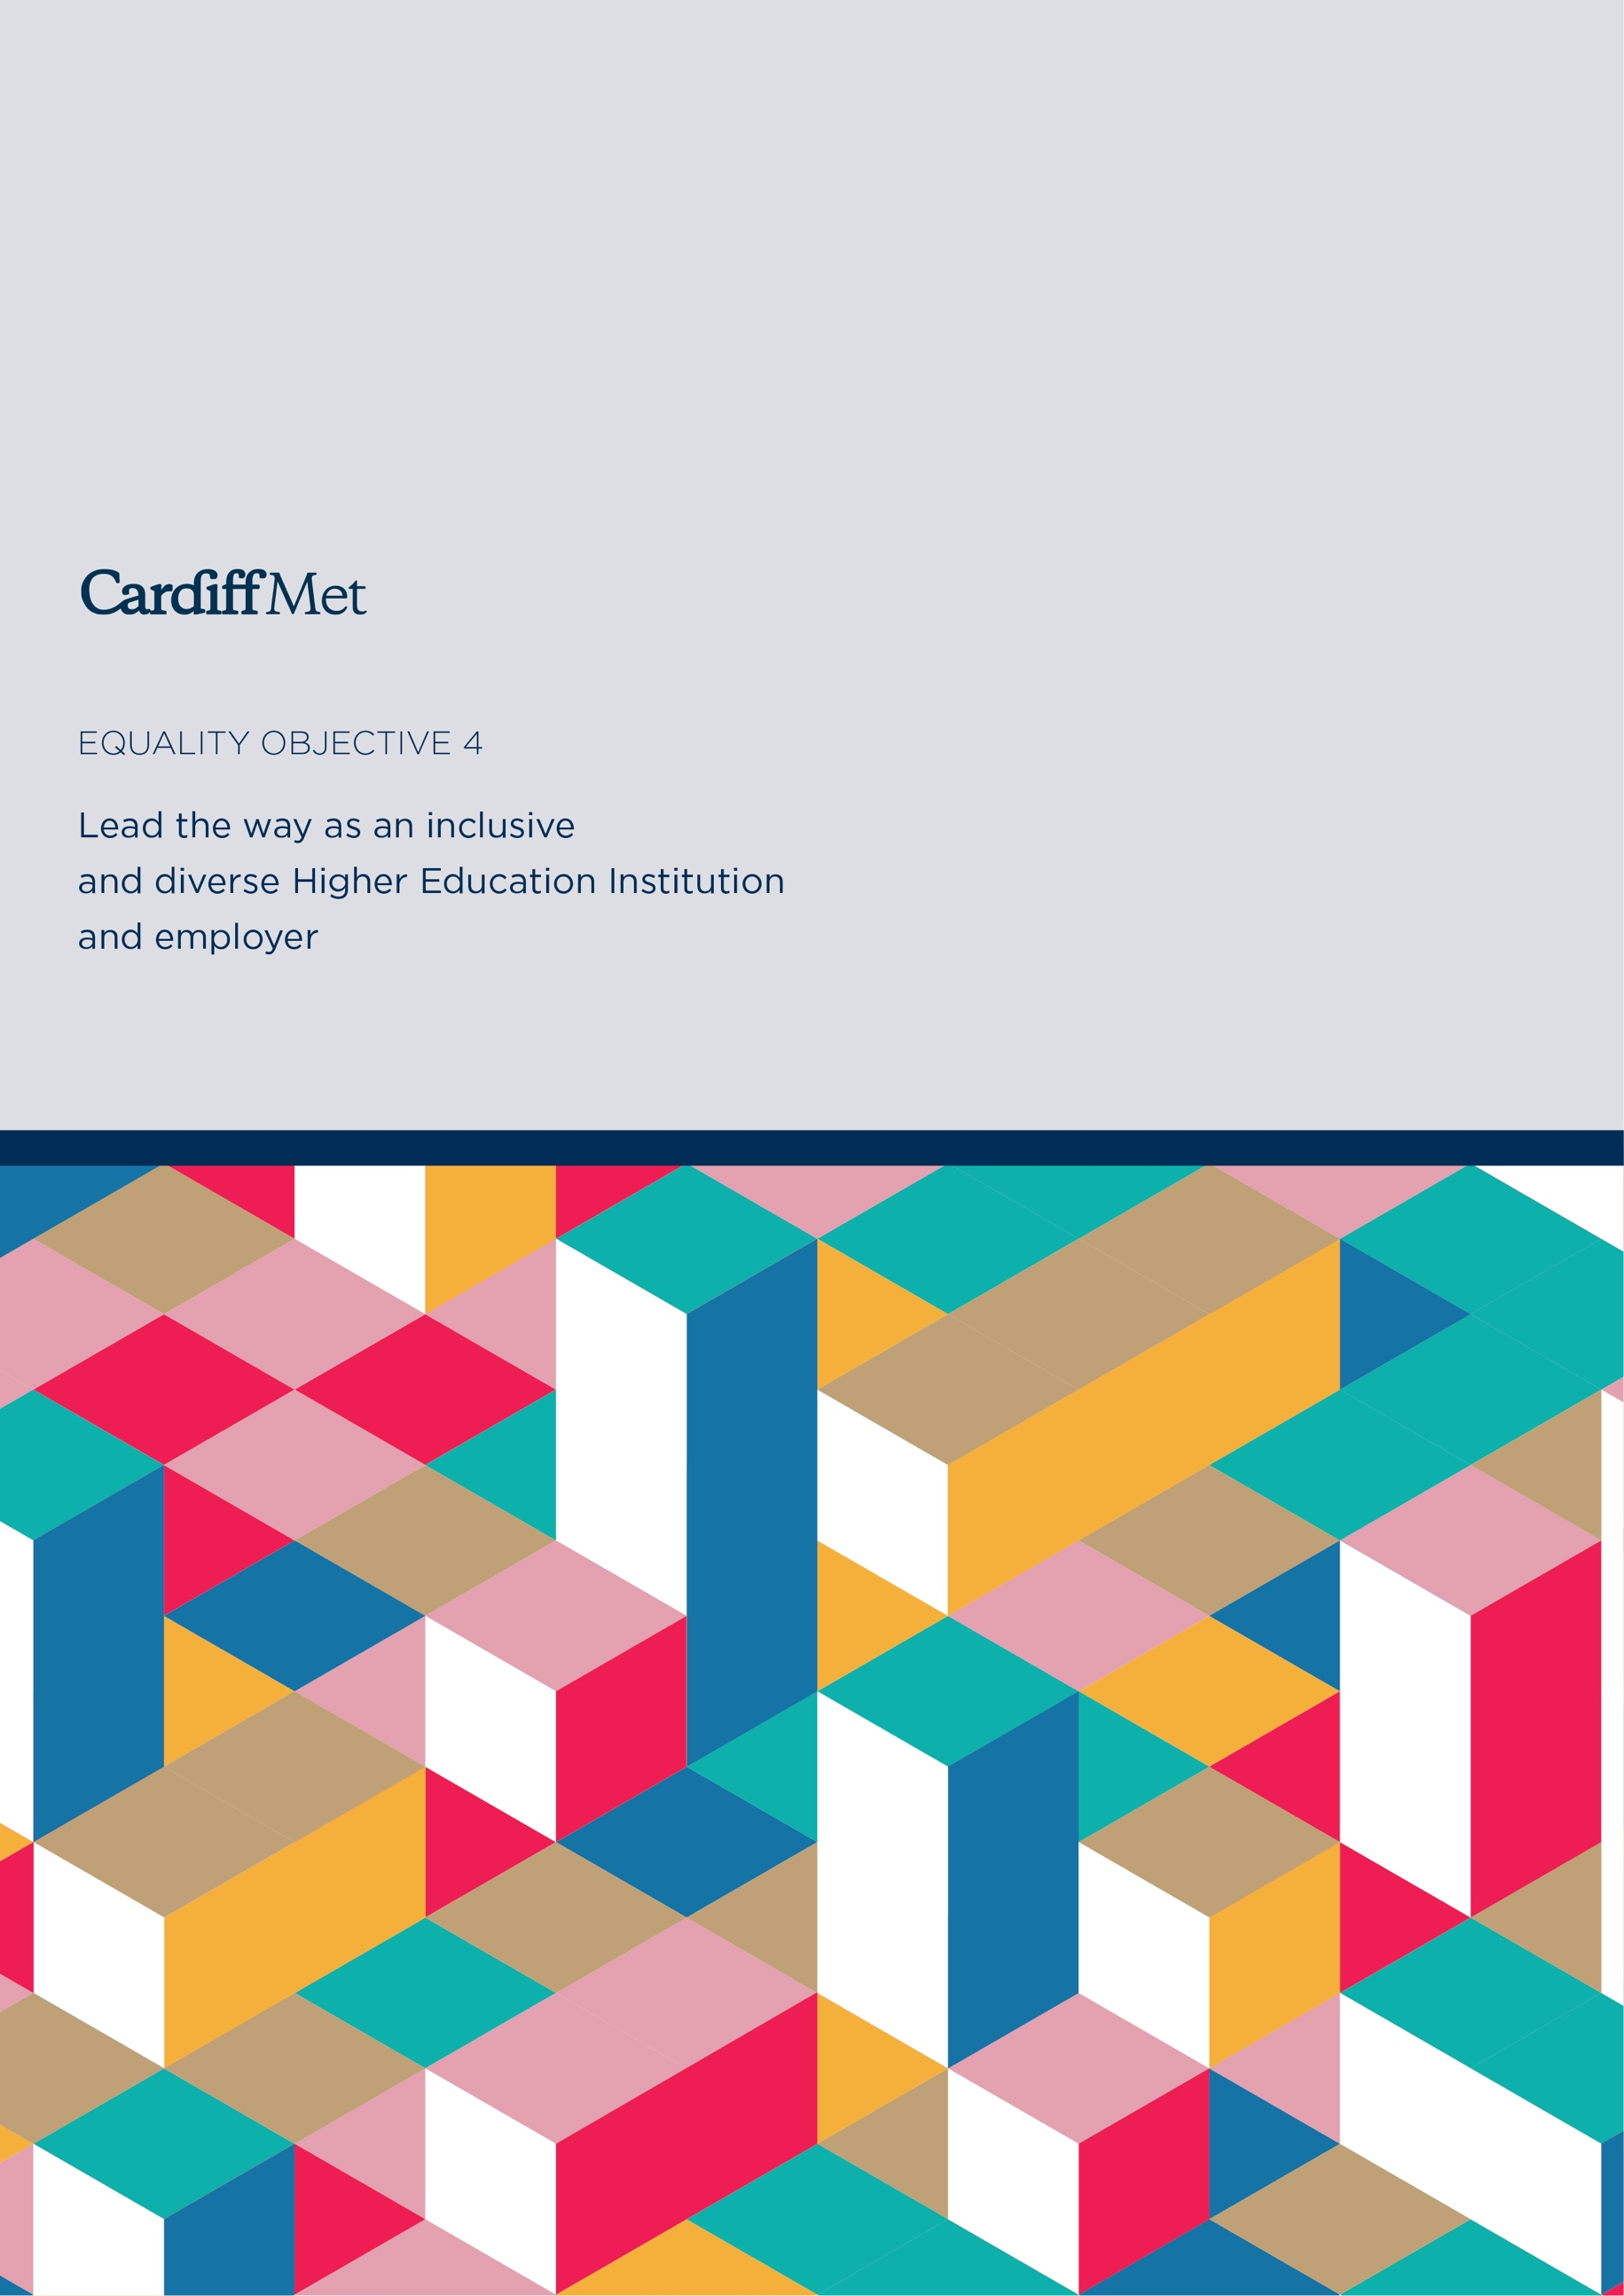

Equality Objective 4:
Lead the way as an inclusive and diverse Higher Education Institution and employer
The University will play an active role to drive equality forward and challenge the inequalities that persist across the Public Sector and Higher Education in Wales.
Priorities

We will:

- Work to secure action on addressing pay gaps between staff who share protected characteristics and those who do not, ensuring accurate data that enables analysis and publish findings (specifically Gender, Race and Disability)

- Continue to undertake annual equal pay for equal work reviews

- Ensure that our policies and procedures are wholly inclusive and that all staff are aware of their content

- Increase workforce diversity to better reflect our community, undertaking a comprehensive review of the recruitment and selection process

- Ensure fit-for-purpose and effective University-level frameworks for promoting equality, diversity and inclusion

- Provide relevant support to staff, through training and career development, to deliver an authentically mainstreamed approach to equality across all areas of the University

- To provide accessible information through a variety of formats and ensuring compliance with The Public Sector Bodies (Websites and Mobile Applications) (No. 2) Accessibility Regulations 2018

- Support the development of an inclusive environment for staff to develop and flourish through the engagement with external charter marks such as Advance HE Charter Marks, and Disability Confident scheme

Monitoring Progress and Delivery

To ensure the delivery of the Plan and its associated objectives, Cardiff Met will drive progress through the Equality and Diversity Delivery Group (EDDG). The committee is chaired by the University Secretary and Clerk to the Board of Governors who will be the responsible Vice-Chancellors Executive Group (VCEG) member.

Our Strategic Equality Plan sets out the key priorities for Cardiff Met over the next 4 years. Not only will these priorities help support our drive for the advancement of equality, diversity and inclusion but will also align with our corporate, school and professional ambitions.

We acknowledge that this Plan will be a living document, which will inevitably have to evolve to reflect the University and our community’s needs. Thus, in addition to the existing mechanisms in place to support the Plan, we will look to establish a self-assessment process to focus on the impact and outcomes of the delivery and implementation of the plan. This will ensure that the process is continuous and becomes embedded into University culture and decision making.

Monitoring data will continue to be essential to providing a robust evidence base to inform and review equality and diversity objectives and implementation. An annual report will be published on progress against out listed objectives and priorities.

Strategic Equality Plan 2020-24 Outcomes

Outcomes
Through the implementation of the Strategic Equality Plan we aim to support the long-term equality aims for Wales and a Wales of cohesive communities. By the end of the Strategic Equality Plan we will:

- Develop accurate equality data across the University
- Work collaboratively to increase diversity of staff and student populations and compare with national benchmarks
- Improve evidence-base to support monitoring and inform action
- Improve retention, learning outcomes and success for groups with protected characteristics
- Improve reporting and increase support for identity-based abuse, harassment, hate crime and bulling
- Evidence that the campus is accessible and inclusive for all, recognising accessibility in its broadest definition and not simply as physical access
- Evidence that the curriculum is inclusive in content and form of delivery
- Contribute to the University’s current and future overarching Corporate Strategic Plans, championing creativity, diversity, freedom and innovation to generate educational transformation, research with impact, sustainable economic growth, social cohesion and health and wellbeing

Strategic Equality Plan 2020-24 Consultation

The Strategic Equality Objectives and high-level actions were developed in collaboration with key internal and external stakeholders.

Internal stakeholder engagement included consultation within the University including Equality and Diversity Delivery Group, Staff Networks, Registry, Quality and Enhancement Directorate, Global Engagement, Student Services, Estates and Facilities, Students’ Union Trade Unions and Board of Governors.

Staff and students were provided the opportunity to feedback on the proposed 4 overarching equality objectives outlined within the Strategic Equality Plan. An online link and information were provided on the internal staff intranet site. This was promoted through various internal communication channels. Face to face consultation was also available. The Students’ Union communicated the link through their own internal channels.

A joint consultative Third Sector Equality Engagement Event was held alongside Cardiff University and University of South Wales to review together equality barriers to Higher Education and the needs of our community on Monday, 8th April 2019. The event was focused around three key themes: Community Engagement & Civic Engagement, Experiences of Students & Potential Students, and Working at a University. Findings of the events helped shape and form the current Strategic Equality Objectives.

Equality Legislation

Strategic Equality Plan
As a listed body in Wales under the Equality Act 2010, Cardiff Metropolitan University is required to draw up a Strategic Equality Plan at least every 4 years. The Plan sets out how we aim to meet our commitment to equality and how we will meet legal obligations contained within the Equality Act 2010.

General Duty
The Equality Act 2010 brought together and replaced previous anti-discrimination laws with a single Act, which legally protects people from discrimination in the workplace and in wider society. The legislation provides protection to people who have ‘protected characteristics:
- Age
- Disability
- Gender Reassignment
- Pregnancy and Maternity
- Marriage and Civil Partnership
- Race
- Religion or Belief
- Sex
- Sexual Orientation
It applies to marriage and civil partnership, but only in respect of the requirement to have due regard to the need to eliminate discrimination.

Within the Equality Act 2010, public bodies, including Higher Education Institutions have an additional responsibility to meet the Public Sector Equality Duty also known as the ‘General Duty’.

The aim of the General Duty is to ensure that public authorities and those carrying out a public function consider how we can positively contribute to a fairer society through advancing equality and good relations in our day-to-day activities. Public bodies, such as Cardiff Metropolitan University are required to have due regard to the need to:

- Eliminate unlawful discrimination, harassment and victimisation and other conduct prohibited by the Act.
- Advance equality of opportunity between people who share a protected characteristic and those who do not.
- Foster good relations between people who share a protected characteristic and those who do not.

Specific Duties
In order to meet the General Duty, Specific Duties have been developed in Wales to outline the requirements placed on public bodies. These are set out in the Statutory Duties (Wales) Regulations 2011. The Specific Duties set out the steps that listed bodies in Wales must take in order to demonstrate that we are meeting the General Duty. Under the Specific Duties, Cardiff Metropolitan University is required to:
- Create an evidence base relevant to their functions
- Engage staff, students and other people
- Assess the impact of policies and practices
- Develop pay differences and objectives
- Develop equality objectives
- Report on compliance with the duty
- Embed equality into all functions

Welsh Language
Although language is not a protected characteristic under the Equality Act 2010 and the protection of the Welsh language is taken forward under separate legislation (the Welsh Language (Wales) Measure 2011 and related Standards) we recognise that Welsh Language and Equality, Diversity and Inclusion agendas can play a significant role in supporting and informing each other. We also recognise that these agendas are supported through the Goal within the Wellbeing of Future Generations Act – A Wales of vibrant culture and thriving Welsh Language. At Cardiff Metropolitan University, we are committed to ensuring that Welsh and English language are treated on a basis of equality when conducting our business in Wales as well as recognising the importance of fostering an environment where Welsh speaking staff, students and the public feel comfortable and confident in engaging with the University through the medium of Welsh.

The Well-being of Future Generations (Wales) Act 2015
The Well-being of Future Generations Act requires public bodies in Wales to think about the long-term impact of their decisions, to work better with people, communities and each other, and to prevent persistent problems such as poverty, health inequalities and climate change. While Higher Education Institutions may not have this duty upon them, we recognise the significant role Universities play in shaping the long-term future of Wales contributing to the seven national well-being goals (Figure 1). Whilst some of the well-being goals specifically relate to equality, we recognise that through the implementation of our Strategic Equality Plan, and the intersectional nature of our objectives, we will be able to contribute significantly all well-being goals.

Figure 1
7 Well-being Goals
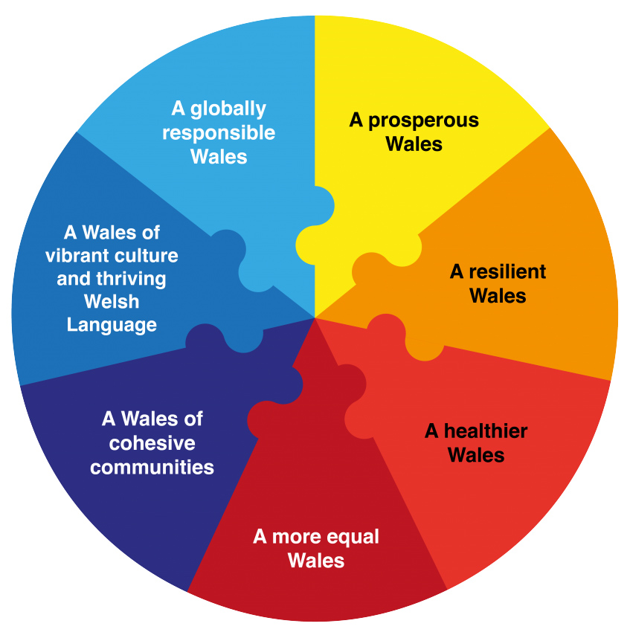

Identifying and Collecting Relevant Equality Information

Collecting and using relevant information is critical in Cardiff Met meeting the General and Specific Equality Duties. It ensures that the University has the best evidence available to enable us to set meaningful objectives and carry out fully informed decision making, initiatives, interventions and assessments. Information is collected from sources including but not limited to:

- Welsh Government, Universities UK, Equality and Human Rights Commission and other relevant publications
- HESA Data
- Staff Monitoring Information
- Student Monitoring Information
- Advance HE
- Regional stakeholder and local engagement and consultation
- Student and Staff complaints
- Athena SWAN Institutional Bronze Application 2016 & renewal 2019
- CSSHS (Health) Athena SWAN Departmental Bronze Application 2017
- CSSHS (Sport) Athena SWAN Departmental Silver Application 2017
- CSAD Athena SWAN Departmental Bronze Application 2018
- Equal Pay Reviews
- Gender Pay Gap Report 2017 & 2019 and associated Action Plan
- Health and Wellbeing Survey 2016, 2018 & 2019

During the implementation of the current plan we are committed to continuing to strengthen the collection, monitoring and analysis of our data by protected characteristics to inform future strategic planning and development.

We will also ensure appropriate arrangements to identify and collect information about differences in pay, and the causes of any such differences, between staff who have a protected characteristic and those who do not.

Publishing Employment Information

As a listed body in Wales, Cardiff Met publishes an Annual Equality Monitoring Report detailing equality related employment information as well as outlining progress in delivering of our Strategic Equality Plan.

The Annual Equality Monitoring Report will be presented to the Equality and Diversity Delivery Group, Management Board and the Board of Governors prior to being published on our external website.

Arrangements for Equality Impact Assessments (EIA)

Further to our commitment to creating a fair and equitable working and learning environment the University will assess all its current, revised and proposed policies, practices and procedures for their impact on protected groups as defined in the Equality Act 2010.

Cardiff Metropolitan has ensured that EIA forms and guidance are in place. The guidance outlines the process that is required to ensure that equality considerations have been made, and there has been appropriate consultation with the relevant stakeholders.

Steps have been taken to ensure that EIAs are embedded within key decision making at the University. We have worked with our Business Improvement Services Team to ensure EIAs are right at the heart of internal projects, while it is also mandatory for all University papers going to decision making bodies to have an accompanying EIA.

An internal achieve of conducted corporate EIAs is held centrally within the University’s Secretariat department. Any EIAs which show a substantial impact (or likely impact) on our ability to meet the general duty will be published in the relevant section of our external website.

Promoting Knowledge and Understanding

To support our commitment to lead the way as an inclusive and diverse Higher Education Institution and employer, all members of Cardiff Met staff are required to undertake mandatory equality in the workplace training as part of their induction process. Training promotes knowledge and understanding of the Equality Act, Specific Duties and the importance of equality, diversity and inclusion at Cardiff Met.

Cardiff Metropolitan University Students’ Union runs annual equality training to all student representatives. An appointed part-time SU Equality and Diversity Officer works closely with the University’s Equality team providing a further platform for the Student Voice.



