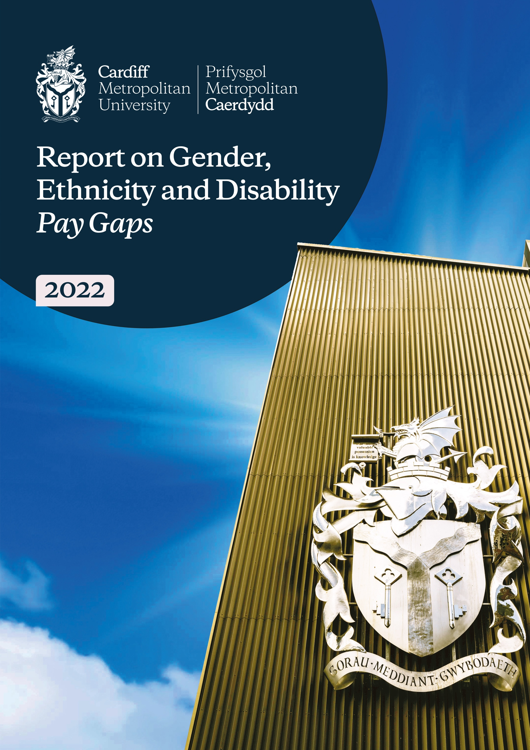


Cardiff Metropolitan University Report on Gender, Ethnicity and Disability Pay Gaps 2022

This report contains the outcomes of Cardiff Metropolitan University’s analysis of the gender, ethnicity and disability pay gaps in 2022. The inclusion of the University’s Ethnicity Pay Gap and Disability Pay Gap analysis is included for the first time this year. Unlike the gender pay gap analysis, these new analyses are not mandatory but form part of the University’s wider commitment to equality, diversity and inclusion. The report therefore reflects the University’s values and strategic ambitions, as exemplified in the new Strategy 2030, and outlines actions taken to address the pay gaps.
Cardiff Met is a progressive university, working with purpose, impact and compassion to make economies more prosperous, societies fairer, cultures richer, environments greener and communities healthier. We work in partnership with our students and staff to transform lives and communities through our high-quality, high-impact education informed by our cutting-edge research and innovation.
Our high-performance culture is steered by our compassionate leadership underpinned by clear values to provide a moral compass that guides the institution, bringing out the best in our students and staff. Compassionate leadership is about listening, leading, coaching and supporting all members of our community to achieve their full potential thus enabling us to achieve our ambitions.
We are committed to social, economic and environmental responsibility. Our education, research and innovation delivers positive impacts for equality, social inclusion and environmental sustainability, locally, nationally and internationally.
Our values of creativity, innovation, inclusivity and trust, supported by our behaviours of leadership, courage, accountability and agility are underpinned by the principles of academic freedom and institutional autonomy which guide us as we collaborate across the globe. Recognising the intersectionality of factors that exclude from education and the benefits and impacts of education, we will continue to tackle discrimination. We will continue to breakdown cultural barriers, making our community more inclusive and representative of those we seek to serve and we will develop our people to reflect our diverse communities, investing in building the skills and attributes needed to work equitably with individuals and groups of all backgrounds in Wales, the UK and globally.

Cardiff Met is an accredited Real Living Wage employer and remains committed to paying its staff in accordance with the Real Living Wage rates. We offer good flexible working arrangements for our people, including options for part-time, job share and hybrid working. We provide regular learning opportunities including leadership development programmes, mentoring and coaching, and skills development to help everyone grow. These opportunities include initiatives tailored to specific groups who are under-represented in parts of our University and are designed to ensure that everyone has the right support to progress their career.

Our employee diversity networks help us to build an inclusive culture for all within the University and, within the new strategic context, will play an even greater role in informing policy and practice across the organisation.

Equality, Diversity, and Inclusion is central to creating and fostering a working and learning environment for all. We engage actively in initiatives that allow us to grow into a more equitable and inclusive University, tackling challenges and disparities that hinder equal representation, progression and outcomes for all. To support our journey at Cardiff Met, we have identified Advance HE’s Race Equality and Athena SWAN Charter Marks as drivers for change.

Since our successful institutional Athena SWAN award in 2019, we have continued to take a whole-institutional approach resulting in all our Academic Schools committing to making individual applications for the Bronze and Silver awards. We will continue to embed and uphold the key principles of Athena SWAN within our University and maintain a practical and informed strategy to advance Gender Equality for all academic and professional staff.

In September 2020, the University made an unwavering commitment to embed racial justice and equality in all parts of our institution, moving beyond talk to transform the agenda into a call to action for everyone within our community and reach. We firmly believe that this is an issue that requires ownership from all to ensure lasting cultural change and that the Race Equality Charter will support us on this journey.

Publishing our Report on Gender, Ethnicity and Disability Pay Gaps 2022 is an important element of our work on inclusivity. In recent years we have made significant progress in closing our gender pay gap which is down from 8.47% last year to 8.42% this year compared to a sector median of 11.1% (UCEA, 2022).

However, we are not complacent, and closing the gender pay gap entirely remains an ongoing priority and commitment.

We will continue to monitor and take action on our pay gaps where they exist, through the University Pay Gap Action Planning Group which was established in 2021 and this group will report recommendations to the University’s Equality, Diversity and Inclusion Committee on an annual basis.

To ensure these strategic ambitions are realised at the earliest opportunity, revisions to the structure and roles within the Vice-Chancellor’s Executive Group will be implemented in early 2023 providing even more visible senior leadership for the equality, diversity and inclusion agenda.

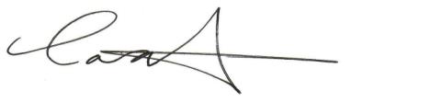
Professor Cara Aitchison
President and Vice-Chancellor
Introduction
As part of statutory requirements under the Equality Act 2010 we report on our annual analysis of the gender pay gap at Cardiff Met.
In addition, for the first time we are also reporting the results of the University’s Ethnicity Pay Gap and Disability Pay Gap analysis.
We prepare this report as part of our equality, diversity, inclusion commitment so that we understand and monitor our position and identify actions to take, regardless of whether it is a statutory requirement.

Definitions
The mean and the median are measures of central tendency within data sets, used as industry standard to analyse pay gaps.

Mean- the mean (average) involves adding together the pay or bonuses of staff and then dividing by the total number of staff.

Median – the median is the middle value of all hourly rates when ranked. That is the amount paid to staff in the middle of the list, if staff are listed in order of pay or bonus. We look at the median as it’s less affected by numbers at the top end of the pay range.

GENDER PAY GAP 2022

Gender Representation within Cardiff Metropolitan University (March 2022)
58.6% of our workforce are women
41.4% of our workforce are men

Cardiff Metropolitan Gender Pay Gap 2022
The gender pay gap shows the difference in the average pay between men and women in the workforce. A gender pay gap is created, for example, when more men than women are employed in senior roles or more women than men are employed in lower paid jobs.

Mean Pay Gap
The mean pay gap is the difference between the average hourly earnings of men and women.

Average mean gender pay gap using hourly pay | 31/03/2019 | 31/03/2020 | 31/03/2021 | 31/03/2022
Female Mean as a Percentage of Male Mean | 9.90 | 11.25 | 11.23 | 11.31

- Our mean pay gap is 11.31%
- The mean pay gap has increased from 11.23% since 2021
At Cardiff Met, our mean pay gap is caused by an over representation of women at our lower grades, which has resulted in the average hourly earnings of women to be lower than that for men.

Median Pay Gap
The median pay gap is the difference between the midpoints in the ranges of hourly earnings of men and women.

Average median gender pay gap using hourly pay | 31/03/2019 | 31/03/2020 | 31/03/2021 | 31/03/2022
Female Median as a Percentage of Male Median | 11.10 | 14.24 | 8.47 | 8.42

- Our median pay gap for women is 8.42%
- The median pay gap has decreased from 8.47% since 2021
Whilst there has been some increase in the representation of women in the top quartile, there has also been an increase in the representation of women in the lower quartile.

Cardiff Metropolitan Gender Bonus Gap 2022

Bonus Pay Gap | 31/03/2019 | 31/03/2020 | 31/03/2021 | 31/03/2022
Percentage of Men Receiving Bonus Pay | 0.4 | 0.5 | 0.73 | 0.35
Percentage of Women Receiving Bonus Pay | 0.2 | 0.2 | 0.84 | 0.16

0.16% of women were awarded a bonus.

0.35% of men were awarded a bonus.

Bonus Pay Gap | 31/03/2019 | 31/03/2020 | 31/03/2021 | 31/03/2022
Women's Bonus Pay Mean Percentage | 18.2 | 1.75 | 49.72 | 18.8
Women's Bonus Pay Median Percentage | 0 | 0 | 84.05 | 0

The mean bonus gap is 18.8%.

The median bonus gap is 0%.

There has been a decrease in the bonus pay gap since March 2021. For many years we have operated a contractual bonus scheme for a very small section of our workforce which has impacted on the gender bonus gap. We have made changes to close this scheme which has positively impacted on this year’s gender bonus gap.

Pay by Quartile

The table below shows hourly pay by quartile for the University. It shows that there is a higher proportion of women in all quartiles, apart from the top quartile compared to men. However, the proportion of women in the lower middle and lower quartiles is significantly higher than the number of men and this is driving our gender pay gap.
At Cardiff Met we operate an incremental progression pay model where employees progress each year through the pay range until they reach the maximum pay point for their grade.

Percentage of men and women in each hourly pay quarter | 31/03/2019 | 31/03/2020 | 31/03/2021 | 31/03/2022
Percentage of Men in Top Quartile | 51.2 | 49.63 | 51.52 | 50.90
Percentage of Women in Top Quartile | 48.8 | 50.37 | 48.48 | 49.10
Percentage of Men in Upper Middle Quartile | 53 | 47.32 | 44.42 | 44.5
Percentage of Women in Upper Middle Quartile | 57 | 52.68 | 55.58 | 55.5
Percentage of Men in Lower Middle Quartile | 34.6 | 34.05 | 36.61 | 39.90
Percentage of Women in Lower Middle Quartile | 65.4 | 65.95 | 63.39 | 60.10
Percentage of Men in Lower Quartile | 40 | 37.16 | 35.01 | 30.40
Percentage of Women in Lower Quartile | 60 | 62.84 | 64.99 | 69.60

ETHNICITY PAY GAP 2022

We calculate ethnicity pay gap in the same way as we calculate gender pay gap and we use the same data collection point of 31st March 2022. This is the first year of publishing our findings.

Our ethnicity data may be influenced because a number of staff have chosen not to voluntarily disclose this information. The University will explore ways of encouraging staff to disclose this information going forward.

We recognise that ‘BAME’ is an imperfect term that encompasses a hugely diverse population who cannot be defined as a single homogenous group. For the purposes of reporting our ethnicity pay gap we use the term BAME to make comparisons between Black, Asian and Minority Ethnic and White staff.

Ethnicity Representation within Cardiff Metropolitan University (March 2022)

9.7% of our workforce are of Black, Asian and Minority Ethnic ethnicity.
88.1% or our workforce are of White ethnicity.
2.2% or our workforce ethnicity is unknown/not declared.
The following data is based on the proportion of staff who declared their ethnicity, i.e. 97.8%.

Cardiff Metropolitan Ethnicity Pay Gap 2022

The ethnicity pay gap shows the difference in the average pay between Black, Asian and Minority Ethnic ethnicity and white ethnicity staff. An ethnicity pay gap is created, for example, when more white staff are employed in senior roles or a greater number of Black, Asian and Minority Ethnic staff than white staff are employed in lower paid jobs.

Ethnicity Mean Pay Gap

The mean pay gap is the difference between the average hourly earnings of Black, Asian Minority Ethnic staff and white staff.

Average mean ethnicity pay gap using hourly pay | 31/03/2012
Black, Asian and Minority Ethnic Mean as a Percentage of White Mean | 3.31

- Our mean pay gap is 3.31 in favour of BAME staff.

Median Pay Gap
The ethnicity median pay gap is the difference between the midpoints in the ranges of hourly earnings of Black, Asian and Minority Ethnic staff and white staff.

Average median ethnicity pay gap using hourly pay | 31/03/2022
Black, Asian and Minority Ethnic Median as a Percentage of White Median | 15.85

- Our median pay gap is 15.85% in favour of BAME staff.
Cardiff Metropolitan Ethnicity Bonus Gap 2022

Due to the very small numbers of staff that received a bonus, the ethnicity bonus gap data cannot be disclosed.

Pay by Quartile

The table below shows the hourly pay by quartile for the University based on Black, Asian and Minority Ethnic and white ethnicity staff. It shows that there is a higher proportion of white ethnicity staff in all quartiles. There is a higher proportion of Black, Asian and Minority Ethnic staff in the top and upper middle quartiles than the lower quartiles.

Percentage of Black, Asian and Minority Ethnic ethnicity staff and white ethnicity staff in each hourly pay quarter | 31/03/2022
Percentage of Black, Asian and Minority Ethnic ethnicity in Top Quartile | 8.84
Percentage of white ethnicity in Top Quartile | 87.50
Percentage of Black, Asian and Minority Ethnic ethnicity in Upper Middle Quartile | 15.45
Percentage of white ethnicity in Upper Middle Quartile | 82.12
Percentage of Black, Asian and Minority Ethnic ethnicity in Lower Middle Quartile | 6.71
Percentage of white ethnicity in Lower Middle Quartile | 91.46
Percentage of Black, Asian and Minority Ethnic ethnicity in Lower Quartile | 7.60
Percentage of white ethnicity in Lower Quartile | 89.06

DISABILITY PAY GAP

We calculate disability pay gap in the same way as we calculate gender pay gap and we use the same data collection point of 31st March 2022. This is the first year of publishing our findings.

Our disability data may be influenced because a number of staff have chosen not to voluntarily disclose this information. The University will explore ways of encouraging staff to disclose this information going forward.

For the purposes of reporting our disability pay gap we make comparisons between staff who have declared whether or not they have a disability.

Disability Representation within Cardiff Metropolitan University (March 2022)

8.3% of our workforce prefer not to say whether or not they have a disability.
91.7% of our workforce declared whether or not they have a disability. Of those who have declared, the breakdown is as follows:
6.1% of our workforce have declared a disability.
93.9% of our workforce have no known disability.
The following data is based on the proportion of staff who declared whether or not they have a disability, i.e. 91.7%.

Cardiff Metropolitan Disability Pay Gap 2022
The disability pay gap shows the difference in the average pay between staff who have declared a disability and staff with no known disability. A disability pay gap is created, for example, when more staff with no known disability are employed in senior roles or more staff with a declared disability are employed in lower paid jobs.

Disability Mean Pay Gap
The mean pay gap is the difference between the average hourly earnings of staff with a declared disability and staff with no known disability.

Average mean disability pay gap using hourly pay | 31/03/2022
Disability Mean as a % of No Known Disability Mean | 6.49

- Our mean pay gap is 6.49 in favour of staff with no known disability.

Median Pay Gap

The disability median pay gap is the difference between the midpoints in the ranges of hourly earnings of staff with no known disability and staff with a declared disability.

Average median disability pay gap using hourly pay | 31/03/2022
Disability Median as a % of No Known Disability Median | 8.43

- Our median pay gap is 8.43% in favour of staff with no known disability.
Cardiff Metropolitan Disability Bonus Gap 2022

Due to the very small numbers of staff that received a bonus, the disability bonus gap data cannot be disclosed.

Pay by Quartile
The table below shows the hourly pay by quartile for the University based on staff with a disability and with no known disability. It shows that there is a higher proportion of staff with no known disability in all quartiles. There is a higher proportion of staff with a declared disability in the lower quartiles than in the top/upper middle quartiles.

Percentage of staff with a disability and with no disability in each hourly pay quarter | 31/03/2022
Percentage with a declared disability in Top Quartile | 5.49
Percentage with no known disability Top Quartile | 87.80
Percentage with a declared disability in Upper Middle Quartile | 3.94
Percentage with no known disability in Upper Middle Quartile | 86.06
Percentage with a declared disability in Lower Middle Quartile | 6.10
Percentage with no known disability in Lower Middle Quartile | 86.28
Percentage with a declared disability in Lower Quartile | 6.69
Percentage with no known disability in Lower Quartile | 82.37

We have a Comprehensive Plan to a more inclusive Employer

To make progress against our ambitions we need to continue to increase representation of women at our senior levels and men at our lower grades. We will achieve this through our recruitment and talent management strategies, flexible working practices and providing a supportive, inclusive environment for all.
This is the first year that we have published both ethnicity and disability pay gap information as part of our wider commitment to improve the representation of Black, Asian and Minority Ethnic (BAME) people and also people with a disability across our workforce. To make progress we are committed to continuously developing an inclusive working environment, giving our people a voice through Staff Networks and working towards gaining the Race Equality Charter mark.

We provide a flexible and inclusive working environment for all through:
- Engaging external organisations such as BITC to explore lived experiences of Black, Asian and Minority Ethnic staff and students.
- Inclusive People policies, including generous annual leave, special leave and shared parental leave provisions. We further extended our provision in response to Covid-19.
- Having flexible working as the standard for most of our roles.
- Having a published University Strategic Equality Plan 2020-24 to underpin our Strategic People Plan.
- Being a Real Living Wage employer.
- Continuing to support our active community of employee diversity networks, including having representatives from a variety of staff networks on the University’s Policy Review Group.
- Continuing to develop our flexible working employment offering post pandemic.
- Continuing the roll out of positive behavioural learning interventions across the organisation, including embedding inclusion and diversity content into our Manage@Met Leadership development programme.
- Manage@Met is our mandatory programme for any staff member in Cardiff Met that line manages another staff member. This programme was launched in May 2021 and has fourteen elements that include: Valuing Equality and Diversity - This focuses on inclusivity for all minority groups and also covers overcoming barriers for staff with a disability and support that may be needed. Leading Hybrid Teams - This covers the importance of equal access to information and development and 1-2-1s to ensure any role that is hybrid has no unintended consequences due to for example child/dependency care or domestic violence Recruitment and Selection Training - This covers unconscious bias and importance of diverse recruitment panels

We continue to ensure our recruitment processes are inclusive, through:
- Ensuring all recruitment panels are diverse and contain members of more than one gender.
- Ensuring vacancies are advertised as flexible by default.
- Ensuring all but very temporary roles are advertised externally using The Times Higher, Jobs.ac.uk, Total Jobs and Indeed.
- Taking positive action and encouraging applicants from diverse and underrepresented groups to apply for positions.
- Introduction of positive action statements, encouraging applicants from underrepresented backgrounds in Higher Education.
- Ensuring all identifiable information is removed as a default from job applications, including: name, age, address and nationality.

We nurture career development through:
- Our women to professor scheme, which provides targeted support for female academic staff to support movement into reader and chair levels. We do this by providing seminars, action learning sets and mentoring sessions. This scheme continued in 2021/22.
- Diversifying membership of our Research Committee to include representatives from our Women’s, LGBTQ+, Disability and BAME Networks to ensure minority and underrepresented voices are heard.
- Implementation of Union Black Training developed by Santander Universities in partnership with the Open University Show the Racism Red Card training.
- Our Disabled network working with OD around deaf awareness and British Sign Language in particular.
- Our internal leadership programmes which have the option to complete a level 5 and level 7 qualification in leadership and management. In 2021/22 we have as follows:
Internal leadership bootcamp programme | 22 participants  3 of these opting to study towards the level 7 qualification | 11 men & 11 women  2 men & 1 woman | Less than 5 Black, Asian and Minority Ethnic ethnicity | 22 no known disability
Leader of Others | 11 participants | 6 men & 5 women | 11 White ethnicity | Less than 5 declared a disability
Leader of Self | 15 participants | 5 men & 10 women | Less than 5 Black, Asian and Minority Ethnic ethnicity | 13 no known disability  Less than 5 preferred not to say

- 5 staff completed level 5 ILM unit in coaching in the period of this report, 3 women and 2 men.
- Our new Performance & Development Review (P&DR) approach launched in April 2020 includes both personal development plans and career development conversations.
- Staff attending external leadership & management development events included:
  - SWIMM: 2 (academic) women, 2 (academic) men.
  - Academi Wales Summer School: 1 (professional services) woman
  - Aurora – 12 women (7 academic and 5 professional services)
- Our university-wide mentoring network.
- Our participation in Advance HE Fellowship and Senior Fellowship workshops.

Data included in this Report
- Salary and workforce information for all staff paid via our payroll as at 31 March 2022 including bonus payments made between 1 April 2021 and 31 March 2022.
- The calculations follow current legislative requirements, and we confirm the data reported is accurate.

