Degree Outcomes Statement


Mae’r ddogfen hon hefyd ar gael yn Gymraeg / This document is also available in Welsh.
- Introduction
This Degree Outcomes Statement forms an annual part of Cardiff Metropolitan University’s core business. It sets out how the institution maintains academic standards and protects the value of its qualifications. It demonstrates that:
- The Board of Governors have confidence that the arrangements in place protect the value of the University’s qualifications.
- Cardiff Metropolitan University can provide Medr with assurance that the University meets national degree standards.
- The University’s methods of calculating undergraduate degree classifications have been in place since 2014 and sit within a stable policy and regulatory framework.

- The University continues to have a strategic focus on clear and achievable teaching, learning and assessment strategies, intended to equip students with a range of subject-specific knowledge and professional skills.

- This document reports on the award outcomes for undergraduate degree students based in the UK.

  - Institutional Degree Classification Profile
Sector outcomes
Institutions across the UK, including Cardiff Metropolitan University, implemented various safety net policies during 2019/20 and 2020/21 in response to the Covid-19 pandemic. This coincided with a sector wide rise in Upper Honours outcomes (First Class or Upper Second-Class honours degrees). This rise has been followed by a subsequent and continued decrease in the sector average. From 82% in 2020/21, it fell to 79% in 2021/22 and to 78% in 2022/23. In 2023/24 the sector average fell again to 77%. This was due to an overall decrease in the sector in the percentage of First Class honours degrees. These fell from 30% in 2022/23 to 29% in 2023/24. The percentage of Upper Second-Class honours degrees remained stable at 48% in 2022/23 and 48% in 2023/24 (HESA, 2025).
Cardiff Metropolitan University outcomes
The proportion of Cardiff Metropolitan students achieving a First Class or Upper Second-Class honours degree increased between the 2017/18 to 2020/21 academic years, peaking at 84.5% in 2020/21. Over successive years the proportion of Upper Honours has fallen to 69.1% in 2022/23, but with a slight rise to 69.7% in 2023/24 (Table 1). However, this remains below the level for the last pre-Covid-19 academic year (2018/19) where the proportion of Upper Honours was 70.6%.
Table 1 shows the ‘Upper Honours’ profile for Cardiff Metropolitan University for the past five academic years - 2019/20 to 2023/24.
Table 1. Cardiff Metropolitan University Upper Honours profile (2019/20 – 2023/24).
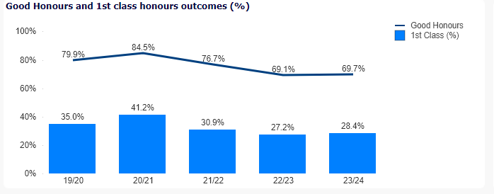
Table 2 shows degree outcomes by all classifications for the academic years 2019/20 to 2023/24 at Cardiff Metropolitan University.
Table 2. Trends in classifications between 2019/20 and 2023/24.
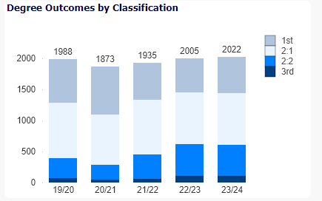
The classification trends shown in Table 2 indicate that the University’s profile of First and Upper Second Class honours degrees increased between 2019/20 and 2020/21. This coincided with the sector wide rise in ‘Upper Honours’ outcomes. After successive falls in 2021/22 (30.9%) and 2022/23 (27.2%) of the percentage of First Class honours degrees, there has been a small increase in the proportion awarded in 2023/24 with a rise of 1.2 percentage points to 28.4% (2023/24). This was at the expense of the other award levels who all saw very marginal falls.
Table 3 shows overall degree outcomes in more detail. It is noted that the 2023/24 First Class honours figure (28.4%) is below the sector average of 29%. The percentage of Upper Second Class awards was 41.2%. A slight fall from 2022/23 (41.9%). The sector average in 2023/24 was 48%. In 2023/24 the percentage of Lower Seconds (25.1%) and Third Class (5.2%) degrees fell by 0.4% and 0.1% respectively from 2022/23. In comparison with the sector, the percentage of Lower Seconds was higher than the sector average of 20%, and the percentage of Thirds were higher than the sector average of 3%.
It can be observed that since 2019/20 the overall general trend has been that the percentage of Lower Seconds and Third Class degrees have both risen whilst the percentage of First Class and Upper Second Class degrees have both fallen.
Table 3. Overall Degree Outcome percentages 2019/20 – 2023/24.
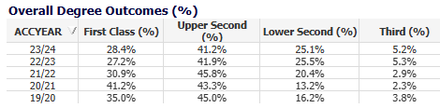
Despite this, Table 4 shows that the percentage of ‘Upper Honours’ outcomes in 2023/24 did rise from the previous level across all student characteristic categories except for Mature students. The decrease for mature students was 0.1%. In comparison with outcomes in the two ‘Covid-19’ years of 2019/20 and 2020/21, outcomes were significantly down across all characteristic groups.
Table 4. Percentage of Upper (Good) Honours degrees awarded to First Degree Students by academic year, broken down by student characteristics.
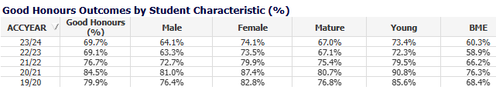
- Assessment and Marking Practices
The University’s assessment and marking practices place a strong emphasis on the constructive alignment of intended learning outcomes, assessment methods and assessment criteria to ensure that assessment is fair, valid, and reliable.
Programmes are approved for delivery following confirmation that the curriculum (including proposed assessment methods) align with the FHEQ/CQFW and any relevant QAA Subject Benchmark Statements or PSRB requirements. Regulations governing marking and moderation are available to staff and students in the Academic Handbook and seek to ensure that marking is fair, consistent, and transparent. The University’s band descriptors steer markers and moderators to the academic standards students are expected to achieve to receive marks in a particular category and map to FHEQ descriptors. The University’s assessment practices are aligned with QAA advice and guidance. Following the recent publication of the revised Quality Code, assessment practices will be re-mapped to the new Principles and Key Practices to ensure continued alignment.
The appropriateness of programme assessment criteria is monitored annually by an External Examiner. In their annual report External Examiners are required to confirm whether standards are appropriate for the award and are aligned to the relevant level of the FHEQ and QAA subject benchmark statements. They are also required to judge whether the standards of awards are comparable to those of other institutions and, where relevant, that they meet PSRB requirements.
External Examiners scrutinise a specified sample of assessed work so that they can make judgements about the standards of student performance and the consistency and fairness of assessment processes. For the 23/24 academic session 100% of External Examiners confirmed that the programmes they considered were aligned with sector benchmarks (including the FHEQ and benchmark statements). 99% of External Examiners also confirmed that programme academic standards were comparable across the UK sector, and 99% agreed that student achievement on programmes aligned with other UK HEIs. For programmes delivered with partners, assessment and marking practices are the same as those described above.
- Academic Governance
The University’s Academic Board is responsible for the standards and quality of all provision that leads to the award of credit in its name. The Academic Quality and Standards Committee (AQSC) is empowered by Academic Board to have oversight, on its behalf, of the academic standards of its awards and for the quality of the student learning experience. On an annual basis the University, through the work of its AQSC, assures its regulator Medr that ‘the standards of awards for which we are responsible have been appropriately set and maintained.’ It does so following scrutiny of a suite of reporting on the University’s programme approval and review processes, annual monitoring processes, assessment processes, and arrangements for Examination Boards. This exercise includes scrutiny of External Examiner reporting on whether assessment designs are appropriate, criteria and marking schemes are set at the right level and whether assessment processes are fair reliable and thorough. For programmes delivered with partners the exercise of authority and oversight is the same as that described above.

- Classification Algorithms
There are two available algorithms for undergraduate honours degrees. However, each individual programme uses only one. The relevant algorithm must be validated and stipulated in each published Programme Specification document. The algorithm will apply consistently to all students on the programme.
Classifications are determined either from:
- the average of the aggregated marks achieved in the best 100 credits at Level 6 (weighted at 0.7) and the next best 100 credits at Level 5 or above (weighted at 0.3); or,
- from the average of the marks achieved in the best 100 credits at Level 6 only.
  - Compensated pass
Students are required to successfully complete all modules registered against their programme in order to qualify for a final award. However, the Examination Board is empowered to award credits for a ‘compensated pass’. This may be done where the module result is a marginal failure, but the student is deemed to have met the minimum learning outcomes across the module and has a Level average which is above the minimum pass mark.
  - Borderline criteria for uplifts
If a student’s overall mark falls within the numerical range for an uplift, the Examination Board will confirm if one is to be awarded by referring to the universally applied criteria:
Any student within 1% of a higher classification is automatically confirmed for an upgrade.
Any student within 2% of a higher classification an Examination Board is empowered to raise the degree class if they fulfil at least one of three specific upgrade criteria:
- Majority of credits in the higher band (50% or more credits at level 6 in the higher classification).
- Exit Velocity based on a comparison of the Level 5 and Level 6 average marks. Where the Level 6 average is in the higher classification band, the Examination Board will normally award the higher class of degree.
- Performance in the major final stage project or dissertation.
  - Resit / retrieval limits
Students can be offered up to two retrieval opportunities, unless prohibited by Programme-specific regulations, or precluded by an Exam Board decision based on their whole academic profile. For example, they have exhausted all attempts for a different module so must be withdrawn. Where reassessment at second or third attempt is necessary, the module is capped at the minimum pass mark. This in line with practice across the sector as outlined in the Universities UK publication 'Understanding Degree Algorithms'.
- Teaching practices and Learning Resources
The University continues to support student continuation, engagement, and award outcomes, through its Assessment and Feedback Policy, Personal Tutoring programme and professional learning offer provided through its Quality Enhancement Directorate (QED). In response to sector developments and student feedback via NSS, SSS and PTES surveys, the University reviewed its Personal Tutor policy and implemented a new Personal Academic Tutoring (PAT) model, with the aim of further extending student support and the development of student communities to promote engagement and learning.
PAT Group sessions help students to adapt to life at Cardiff Met, developing academic and professional skills. Going forward they provide focused, systematic, and timely academic support throughout the student lifecycle. In addition, students are also able to make one-to-one appointments with their Personal Academic Tutor to discuss individual issues. The PAT scheme will ensure that all students receive sufficient and consistent access to support and guidance throughout their time at Cardiff Met.
As an Adobe Creative Campus, university staff and students get free access to Adobe Express. Students can use Adobe Express, which runs on mobile and desktop devices, to create engaging web pages, videos, podcasts and presentations as part of their assessments. The software is being used to enrich learning and teaching, support student experience and build employability skills.
During the 2023/24 session QED continued to roll out its new process in which external examiner reports trigger a targeted learning support offer where a particular challenge has been identified. It is hoped the process will continue to target professional learning support where it can be most impactful.
- Identifying Good Practice and Actions
Good practice in the area of assessment and student outcomes identified through external review, external examiner reporting and programme enhancement planning include:

- External Examiners felt strongly that programmes provide good opportunities to develop students’ employability and digital skills appropriate for the career areas graduates would likely pursue.

- External examiners report high levels of satisfaction with the level of student achievement and with the conduct of assessment.

- NSS results for the Assessment and Feedback theme are 3.9% above the UK sector average.

- Embedding employability into the curriculum including developing current student and alumni networks, in-curricula opportunities to gain additional qualifications, increasing the number of guest speakers from industry and Careers Service collaboration in programme development.

- In support of student retention and success, the continued development of MetStats, providing Personal Academic Tutors (PAT) and Support Services with a comprehensive overview of student engagement and academic progress.
Good practice is disseminated via the University’s Quality Enhancement Directorate through workshops, online videos and guides and its annual Quality Enhancement Conference.

References
HESA (2025) What are HE students’ progression rates and qualifications? [online]. Cheltenham: HESA. Available from https://www.hesa.ac.uk/data-and-analysis/students/outcomes#classifications [Accessed 14 October 2025].

