Degree Outcomes Statement 2021-22



Mae’r ddogfen hon hefyd ar gael yn Gymraeg / This document is also available in Welsh.

Introduction
This Degree Outcomes Statement forms an annual part of Cardiff Metropolitan University’s core business. It sets out how the institution maintains academic standards and protects the value of its qualifications. It demonstrates that:
- The Board of Governors have confidence that the arrangements in place protect the value of the University’s qualifications.
- Cardiff Metropolitan University can provide HEFCW with assurance that the University meets national degree standards.
- The University’s method of calculating undergraduate degree classifications has been in place since 2014 and sits within a stable policy and regulatory framework.
- The University continues to have a strategic focus on clear and achievable teaching, learning and assessment strategies, intended to equip students with a range of subject-specific knowledge and professional skills.

Institutional Degree Classification Profile
Whilst the proportion of Cardiff Metropolitan students achieving a First Class or Upper Second Class honours degree (referred to as ‘Good Honours’) increased between the 2017/18 to 2020/21 academic years, the proportion fell from 84.5% in 2020/21 to 76.7% in 2021/22. However, this still surpasses the target set out in the University’s Measures of Success for 2021/22 and that set for 2022/23 (70%).

The ‘Good Honours’ sector average for 2021/22 was 78%, down from 82% in 2020/21. There was an overall decrease in the sector in the percentage of First Class honours degrees from 36% in 2020/21 to 32% in 2021/22. Second Class honours degrees remained stable at 46% over both years (HESA (2023).

Table 1 shows the ‘Good Honours’ profile for Cardiff Metropolitan University for the academic years 2017/18 to 2021/22.

Table 1. Cardiff Metropolitan University Good Honours profile (2017/18 – 2021/22).

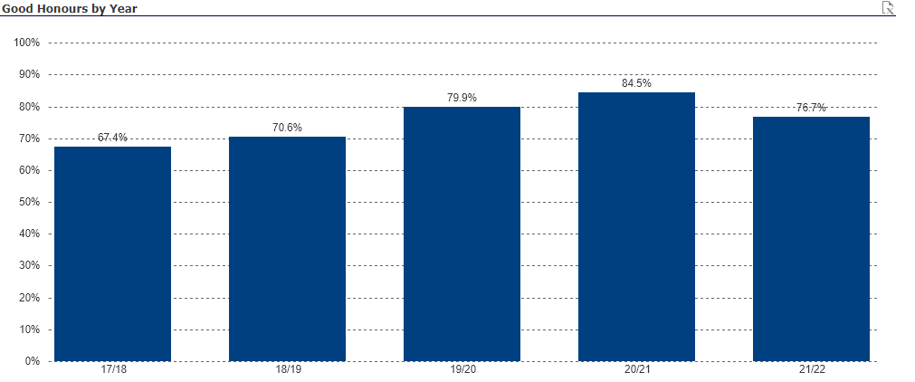

Exceptional Mitigation due to the Covid-19 Pandemic
In common with the majority of the Higher Education sector, Cardiff Metropolitan University introduced a range of measures to support student wellbeing and academic achievement during the exceptional circumstances of the Covid-19 pandemic. Students graduating in the 2021/22 academic year would have been taught and assessed at Levels 4 and 5 under these measures. However, marks achieved at Level 4 would not have been included in the calculation of degree outcomes as Cardiff Metropolitan University’s degree classification algorithm does not include Level 4 marks. It is based only on outcomes achieved at Levels 5 and 6.

During 2020/21 Cardiff-based students would have been covered by Phase 3 of the University’s ‘No Detriment’ policy. This would have covered Level 5 modules for students graduating in 2021/22.

The aspects of the policy which may have applied to students being assessed at Level 5 in 2021/22 were:

- Students who qualified (by attempting the summative assessment in question) were entitled to one reinstated attempt for any (re)assessment in 2020/21, regardless of whether they had passed or failed.
- An enhanced moderation of module results was undertaken, whereby the whole cohort’s results were benchmarked against previous module performance. If the module’s 2020/21 results were lower on average than those achieved pre-pandemic, the marks of all students who had passed the module were adjusted proportionally by the Examination Board (unless capped at the minimum pass mark due to previous failure).

In 2021/22, modules assessed at Level 6 were not covered by a ‘No Detriment’ policy. Instead, they were assessed under the University’s standard academic regulations

Table 2 shows that that the University’s profile of First and Upper Second Class honours degrees grew between 2017/18 and 2020/21. This coincided with a sector wide rise in ‘Good Honours’ outcomes. However, in 2021/22, the numbers of First-Class honours degrees fell, although the numbers remained higher than in the pre-Covid-19 years of 2017/18 and 2018/19. Meanwhile, the number of Upper Second Class degrees rose slightly, as did the number of Lower Second Class degrees and to a lesser extent, the number of Thirds (see Table 3).

Table 2. Trends in classifications between 2017/18 and 2021/22.

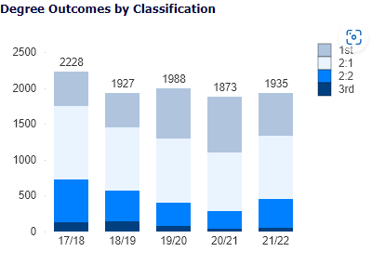

Table 3 shows in more detail that the percentage of First Class awards fell to 30.9% but still remained above pre-Covid-19 levels (as compared with the 2018/19 outcomes). This figure is slightly below the sector average of 32%. The percentage of Upper Second Class awards was 45.8%, which was an increase of 2.5% since 2020/21. This was a return to pre-Covid-19 levels after a slight drop in 2019/20 and 2020/21. The figure remained broadly in line with the wider sector average of 46% in 2021/22. The percentage of Lower Seconds (20.4%) and Third Class (2.9%) degrees increased in 2021/22 but both remained lower than in the pre-Covid-19 years. The percentage of Lower Seconds was higher than the sector average of 17%, which had increased from 14% in 2020/21, but the percentage of Thirds were lower than the 4% sector average which had increased from 3% in 2020/21.

Table 3. Overall Degree Outcome percentages 2017/18 – 2021/22

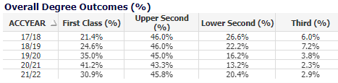
Table 4 shows that the percentage of ‘Good Honours’ outcomes fell across all student characteristics in 2021/22. However, for female, male, mature and BME students, the outcomes did remain above pre-Covid-19 levels. In the case of BME students, there was a fall of 7% between 2020/21 and 2021/22. Nevertheless, in comparison with the final pre-Covid-19 year (2018/19) the ‘Good Honours’ outcomes were still 14% higher. However, the percentage of young students achieving a good honours award was slightly lower than at pre-Covid-19 levels: a fall of 0.9% when comparing 2018/19 with 2021/22.

Cardiff Metropolitan University continues to pursue ways to address the awarding gap through the work of its Race Equality Charter Group.

Table 4. Percentage of Good Honours degrees awarded to First Degree Students by academic year, broken down by student characteristics.

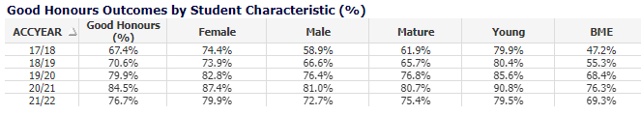

Assessment and Marking Practices
The University’s assessment and marking practices place a strong emphasis on the constructive alignment of intended learning outcomes, assessment methods and assessment criteria to ensure that assessment is fair, valid, and reliable. Programmes are approved for delivery following confirmation that the curriculum (including proposed assessment methods) align with the FHEQ/CQFW and any relevant QAA Subject Benchmark Statements or PSRB requirements. Regulations governing marking and moderation are available to staff and students in the Academic Handbook and seek to ensure that marking is fair, consistent, and transparent. The University’s band descriptors steer markers and moderators to the academic standards students are expected to achieve to receive marks in a particular category and map to FHEQ descriptors. The University’s assessment practices were mapped against the revised QAA Quality Code in 2019 and it was confirmed that they continue to map to QAA Expectations and Practices.
The appropriateness of programme assessment criteria is monitored annually by an External Examiner. In their annual report External Examiners are required to confirm whether standards are appropriate for the award and are aligned to the relevant level of the FHEQ and QAA subject benchmark statements. They are also required to judge whether the standards of awards are comparable to those of other institutions and, where relevant, that they meet PSRB requirements.
External Examiners scrutinise a specified sample of assessed work so that they can make judgements about the standards of student performance and the consistency and fairness of assessment processes. For the 21/22 academic session 100% of External Examiners confirmed that the programmes they considered were aligned with sector benchmarks (including the FHEQ and benchmark statements). 98.8% of External Examiners confirmed that academic standards and student achievement on programmes aligned with other UK HEIs. For programmes delivered with partners, assessment and marking practices are the same as those described above.

Academic Governance
The University’s Academic Board is responsible for the standards and quality of all provision that leads to the award of credit in its name. The Academic Quality and Standards Committee (AQSC) is empowered by Academic Board to have oversight, on its behalf, of the academic standards of its awards and for the quality of the student learning experience. On an annual basis the University, through the work of its AQSC, assures its regulator HEFCW that ‘the standards of awards for which we are responsible have been appropriately set and maintained.’ It does so following scrutiny of a suite of reporting on the University’s programme approval and review processes, annual monitoring processes, assessment processes, and arrangements for Examination Boards. This exercise includes scrutiny of External Examiner reporting on whether assessment designs are appropriate, criteria and marking schemes are set at the right level and whether assessment processes are fair reliable and thorough. For programmes delivered with partners the exercise of authority and oversight is the same as that described above.

Classification Algorithms
There are two available algorithms for undergraduate honours degrees. However, each individual programme uses only one. The relevant algorithm must be validated and stipulated in each published Programme Specification document. The algorithm will apply consistently to all students on the programme.

Students are required to successfully complete all modules registered against their programme in order to qualify for a final award. However, the Examination Board is empowered to award credits for a ‘compensated pass’. This may be done where the module result is a marginal failure, but the student is deemed to have met the minimum learning outcomes across the module and has a Level average which is above the minimum pass mark.
Classifications are determined either from:
- the average of the aggregated marks achieved in the best 100 credits at Level 6 (weighted at 0.7) and the next best 100 credits at Level 5 or above (weighted at 0.3); or,
- from the average of the marks achieved in the best 100 credits at Level 6 only.

Borderline criteria for uplifts
If a student’s overall mark falls within the numerical range for an uplift, the Examination Board will confirm if one is to be awarded by referring to the universally applied criteria:

Any student within 1% of a higher classification is automatically confirmed for an upgrade.

Any student within 2% of a higher classification an Examination Board is empowered to raise the degree class if they fulfil at least one of three specific upgrade criteria:

- Majority of credits in the higher band (50% or more credits at level 6 in the higher classification).
- Exit Velocity based on a comparison of the Level 5 and Level 6 average marks. Where the Level 6 average is in the higher classification band, the Examination Board will normally award the higher class of degree.
- Performance in the major final stage project or dissertation.

Resit / retrieval limits
Students can be offered up to two retrieval opportunities, unless prohibited by Programme-specific regulations, or precluded by an Exam Board decision based on their whole academic profile. For example, they have exhausted all attempts for a different module so must be withdrawn. Where reassessment at second or third attempt is necessary, the module is capped at the minimum pass mark. This in line with practice across the sector as outlined in the Universities UK publication 'Understanding Degree Algorithms'.

Teaching practices and Learning Resources
The University continues to support student continuation, engagement, and award outcomes, through its Assessment and Feedback Policy, Personal Tutoring Policy and professional learning offer provided through its Quality Enhancement Directorate (QED). In response to student feedback in recent NSS, SSS and PTES surveys a standardised approach to assessment briefs has been rolled out across the institution. The intention is to improve consistency and clarity of the assessment process for all students. During the 22/23 session QED are rolling out a new process in which external examiner reports trigger a targeted learning support offer where a particular challenge has been identified. It is hoped the process will help target professional learning support where it can be most impactful.

Identifying Good Practice and Actions
Good practice in the area of assessment and student outcomes identified through the programme enhancement planning rounds include:

- A revised mid-module evaluation process designed and trialled with students. Problem based and interdisciplinary learning on Field 5 term 2 modules praised by students and external examiners.
- Student centred design and transformational learning environment noted by External Examiners. Use of video-based assessments and audio feedback.
- The strategic work with the careers service to enhance in-curricular and extra-curricular student engagement has been recognised by the careers service as practice for dissemination to other schools.
- Development and delivery of shared modules across the UG Health portfolio and embedding of Shape Your Future (being disseminated by Careers Service to other schools).
- Transitioning international colleagues and support packages for new teaching staff, collaborative work with QED which will be used as a roadmap for the development of standardised support for use across all schools.
Good practice is disseminated via the University’s Quality Enhancement Directorate through workshops, online videos and guides and its annual Quality Enhancement Conference.
References
HESA (2023) What are HE students’ progression rates and qualifications? [online]. Cheltenham: HESA. Available from https://www.hesa.ac.uk/data-and-analysis/students/outcomes#classifications [Accessed 21 September 2023].

