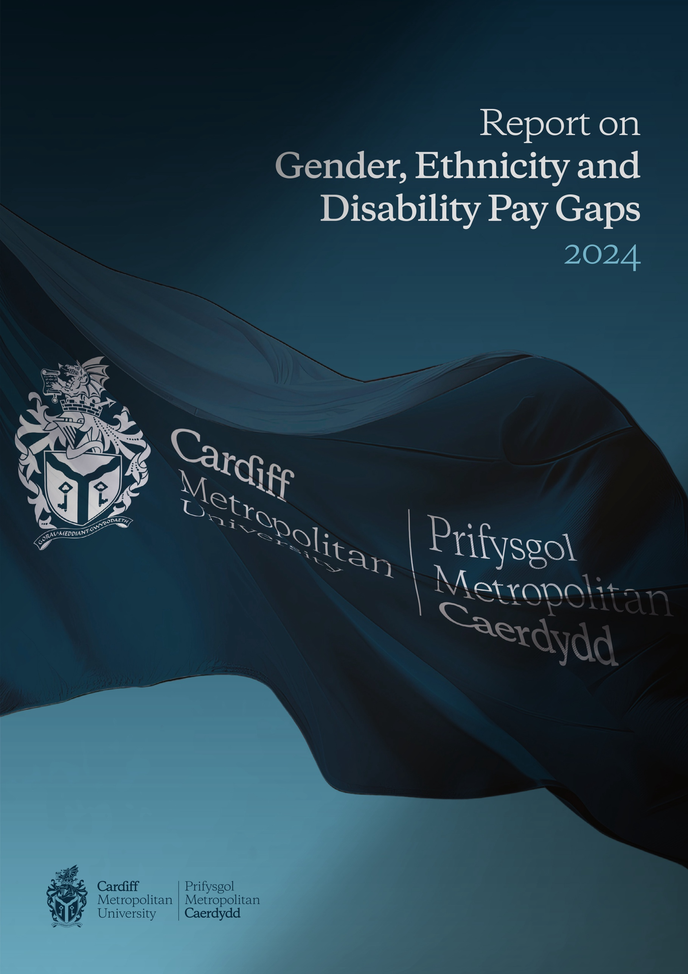

Welcome



This report contains the findings from Cardiff Metropolitan University's examination of gender, ethnicity, and disability pay disparities within its workforce for the year 2024. It aligns with the University’s core values and strategic objectives, particularly as outlined in the newly launched Strategy 2030. The document details both the measures already undertaken to address these pay gaps and the planned initiatives for future improvement.

As a certified Real Living Wage employer, Cardiff Metropolitan University is dedicated to compensating its staff in accordance with Real Living Wage standards. We offer flexible working arrangements that, based on feedback from staff surveys, are highly valued. Our commitment to employee development is reflected in the regular learning opportunities we provide, including leadership development programs, mentoring, coaching, and skills enhancement. These initiatives are specifically designed to support underrepresented groups within the University, ensuring that every individual receives the necessary resources to advance in their careers.

Building on the groundwork established by our previous initiatives, our Strategic Equality Plan 2024-28 will challenge the University to enhance its performance across all functions, placing a strong emphasis on equality, diversity, and inclusion. Our objective is to foster an environment where every member of our community feels welcomed and empowered to reach their full potential.

The publication of our Report on Gender, Ethnicity, and Disability Pay Gaps 2024 is a vital part of our ongoing commitment to inclusivity, with the ultimate goal of eliminating all pay disparities across the institution.



Professor Rachael Langford
President and Vice-Chancellor

Introduction

As part of statutory requirements under the Equality Act 2010, we report on our annual analysis of the gender pay gap at Cardiff Metropolitan University

In addition, for the third consecutive year we are reporting the results of the University’s Ethnicity Pay Gap and Disability Pay Gap analysis and for the second time considering intersectionality data.

We prepare this report as part of our equality, diversity, and inclusion commitment so that we understand and monitor our position and identify actions to take, regardless of whether it is a statutory requirement.

Our demographic data:

The data below provides a breakdown of staff demographics by sex, ethnicity and disability as at March 2024.

Table 1: Staff Demographics by Sex
Sex | Staff (March 2024) |  | Census 2021 Benchmark
Sex | N | % | %
Male | 809 | 42 | 49
Female | 1133 | 58 | 51

Table 2: Staff Demographics by Ethnicity
Ethnicity | Staff (March 2024) |  | Census 2021 Benchmark
Ethnicity | N | % | %
White | 1647 | 84 | 82
Black, Asian and Minority Ethnic (BAME) | 243 | 13 | 18
Unknown | 52 | 3 | -

Table 3: Staff Demographics by Disability
Disability | Staff (March 2024) |  | Census 2021 Benchmark
Disability | N | % | %
No Disability | 1488 | 77 | 82
Disability | 155 | 8 | 18
Unknown | 299 | 15 | -

Definitions

What is Equal Pay?

Equal pay looks at the pay differences between men and women who carry out the same jobs, similar jobs or work of equal value. Cardiff Met supports the principle of equal pay for work of equal value and its systems, practices and policies are based on these principles.

What is the Pay Gap?

The gender pay gap is the percentage difference in the average hourly rate of pay of male and female employees. We have published our numbers in line with the gender pay gap reporting guidelines.

The ethnicity pay gap is the percentage difference in the average hourly rate of pay of white and black, Asian and minority ethnic employees. We calculate our ethnicity pay gap using the same methodology set out in the government regulations for calculating our gender pay gap

The disability pay gap is the percentage difference in the average hourly rate of pay of employees with a disability and those who do not have a disability. We calculate our disability pay gap using the same methodology set out in the government regulations for calculating our gender pay gap

Mean and Median

The mean and the median are measures of central tendency within data sets, used as industry standard to analyse pay gaps.

Mean- the mean (average) involves adding together the pay or bonuses of staff and then dividing by the total number of staff.

Median – the median is the middle value of all hourly rates when ranked. That is the amount paid to staff in the middle of the list, if staff are listed in order of pay or bonus. We look at the median as it’s less affected by numbers at the top end of the pay range.

Gender Pay Gap

Gender Representation within Cardiff Metropolitan University (March 2024)

On 31 March 2024, the University employed 1942 staff as defined by the Gender Pay Gap reporting guidelines*, of which 58.3% are Female and 41.7% are Male.

Cardiff Metropolitan Gender Pay Gap 2024
The gender pay gap shows the difference in the average pay between men and women in the workforce. A gender pay gap is created, for example, when more men than women are employed in senior roles or more women than men are employed in lower paid roles.

Mean Gender Pay Gap
The mean pay gap is the difference between the average hourly earnings of men and women.
Table 4: Mean Gender Pay Gap Over Time
 | 31/03/2020 | 31/03/2021 | 31/03/2022 | 31/03/2023 | 31/03/2024
Mean Pay Gap (%) | 11.25 | 11.23 | 11.31 | 9.98 | 7.78

- Our mean gender pay gap is 7.78% in favour of males.
- The mean gender pay gap has decreased by 2.2% since 2023

The Mean gap has decreased due to 25% of all female starters being in the top or top middle quartile, which has offset new starters in the lower Quartile. The 50% growth in the male population in the lower quartile is also a contributing factor in the mean difference.
At Cardiff Met, our pay gap is caused by an over representation of women at our lower grades, which has resulted in the average hourly earnings of women to be lower than that for men. The presence of two senior management vacancies for roles previously held by women influenced the mean pay gap negatively in 2024.
Median Gender Pay Gap

The median pay gap is the difference between the midpoints in the ranges of hourly earnings of men and women.
Table 4: Median Gender Pay Gap Over Time
 | 31/03/2020 | 31/03/2021 | 31/03/2022 | 31/03/2023 | 31/03/2024
Median Pay Gap (%) | 14.24 | 8.47 | 8.42 | 6.87 | 11.04

- Our median gender pay gap is 11.04%
- The mean gender pay gap has increased by 4.17% since 2023

Whilst there has been a 31% increase in the representation of women in the top quartile, there has also been a 26% increase in representation of women in the lower middle quartile and a 14% increase in the representation of women in the lower quartile.
The meaningful increase in the Median is attributed to the growth in the population, with an additional 239 female and 156 male staff in this year’s population. Female staff account for 62.96% of the lower quartile and 64.4% of the lower middle quartile which has lowered the median hourly rate from £21.42 last year to £20.38 in this year’s population. The male median hourly rate has also decreased from £23 to £22.91 this year.

The population increase of 395 between 2023 and 2024 is attributed to a growth in core staff numbers, coupled with presence of higher numbers of Associate Tutors and Casual staff. In 2023, there were two members of staff on casual contracts and three Associate Tutors present in the pay gap analysis. In 2024 there are 211 staff on casual contracts and 84 Associate Tutors present, which is an increase of 290. Of the 295 in this year’s analysis, 112 (38%) are male and 183 (62%) are female. Despite consistent snapshot dates year to year, this group of staff are paid in arrears therefore presence in the Gender Pay Gap analysis can vary based on both the submission date of pay timesheets and whether work has been conducted in the reporting pay period.
The above is reflected in the quartile data in figures 3 and 4. The number of males has increased by 23% from the previous collection date however the female staff count showed a 27% growth on the previous population. The largest growth in quartile was by female staff in the lower middle quartile with an increase of 83 staff, the second largest area of growth was in the top quartile with an increase of 63 staff members. For Male staff, the biggest increase in headcount was in the lower quartile with 60 additional staff on the previous year, followed by the upper middle quartile with an additional 54 staff.
Between April 2023 and March 2024, we have recruited 230 core staff, 98 male and 132 female.
Figure 1: Headcount by gender – March 2024

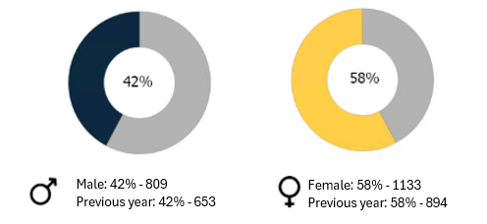

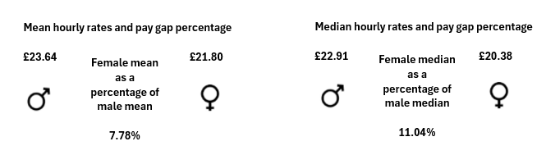
Figure 2: Mean and Median hourly rates and pay gap percentage

Cardiff Metropolitan University Gender Bonus Gap 2024

Table 5: Percentage Receiving Bonus Pay by Gender Over Time
Bonus Pay Gap | 31/03/2020 | 31/03/2021 | 31/03/2022 | 31/03/2023 | 31/03/2024
Percentage of Men Receiving Bonus Pay | 0.5 | 0.73 | 0.35 | 0 | 0
Percentage of Women Receiving Bonus Pay | 0.2 | 0.84 | 0.16 | 0 | 0

- 0% of women were awarded a bonus.
- 0% of men were awarded a bonus.

Table 6: Women’s Bonus Pay Over Time
Bonus Pay Gap | 31/03/2020 | 31/03/2021 | 31/03/2022 | 31/03/2023 | 31/03/2024
Women's Bonus Pay Mean Percentage | 1.75 | 49.72 | 18.8 | 0 | 0
Women's Bonus Pay Median Percentage | 0 | 84.05 | 0 | 0 | 0

- The mean bonus gap is 0%.
- The median bonus gap is 0%.

There has been a decrease in the bonus pay gap since March 2021. For many years we operated a contractual bonus scheme for a very small section of our workforce which has impacted on the gender bonus gap. This scheme no longer exists which has positively impacted on the gender bonus gap and for the second consecutive year this is now 0%.

Pay by Quartile – Gender

The tables below show hourly pay by quartile for the University. It shows that there is a higher proportion of women in all quartiles compared to men. However, the proportion of women in the lower middle and lower quartiles is higher than the number of men and this is driving our gender pay gap.

At Cardiff Met we operate an incremental progression pay model where employees progress each year through the pay range until they reach the maximum pay point for their grade. This does mean that individuals may move between quartiles without any contractual change.

Figure 3: Headcount by quartile - 2023
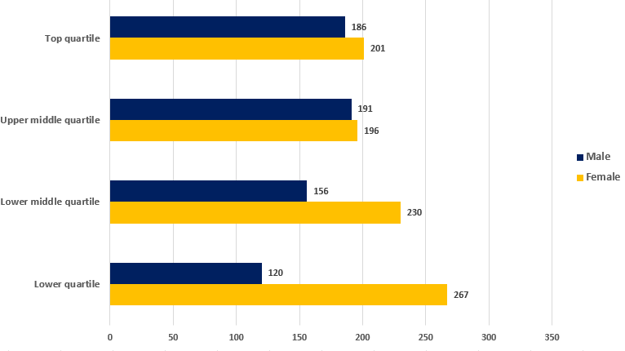

Figure 4: Headcount by quartile – 2024
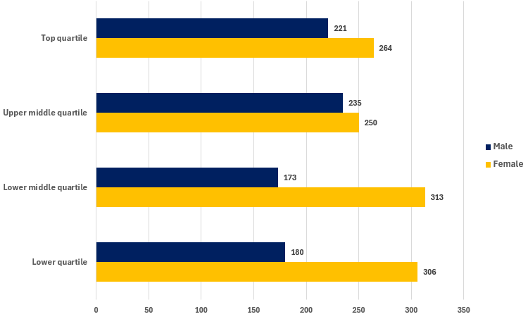

Table 7: Hourly Pay Quarter by Gender
Percentage of men and women in each hourly pay quarter | 31/03/2020 | 31/03/2021 | 31/03/2022 | 31/03/2023 | 31/03/2024
Percentage of Men in Top Quartile | 49.63 | 51.52 | 50.90 | 48.06 | 45.57
Percentage of Women Top Quartile | 50.37 | 48.48 | 49.10 | 51.94 | 54.43
Percentage of Men in Upper Middle Quartile | 47.32 | 44.42 | 44.5 | 49.35 | 48.45
Percentage of Women in Upper Middle Quartile | 52.68 | 55.58 | 55.5 | 50.65 | 51.55
Percentage of Men in Lower Middle Quartile | 34.05 | 36.61 | 39.9 | 40.41 | 35.6
Percentage of Women in Lower Middle Quartile | 65.95 | 63.39 | 60.1 | 59.59 | 64.4
Percentage of Men in Lower Quartile | 37.16 | 35.01 | 30.4 | 31.01 | 37.04
Percentage of Women in Lower Quartile | 62.84 | 64.99

Ethnicity Pay Gap

We calculate the ethnicity pay gap in the same way as we calculate the gender pay gap and we use the same data collection point of 31st March 2024. This is the third consecutive year of publishing our findings.
Our ethnicity data may be influenced by a number of staff who have chosen not to voluntarily disclose this information. The University will continue to explore ways of encouraging staff to disclose this information going forward.
We recognise that ‘BAME’ is an imperfect term that encompasses a hugely diverse population that cannot be defined as a single homogenous group. For the purposes of reporting our ethnicity pay gap, we use the term BAME to make comparisons between Black, Asian and Minority Ethnic and White staff.

Ethnicity Representation within Cardiff Metropolitan University (March 2024)

The following data below is based on the proportion of staff who declared their ethnicity (97%).

Figure 5: Headcount by Ethnicity – March 2024

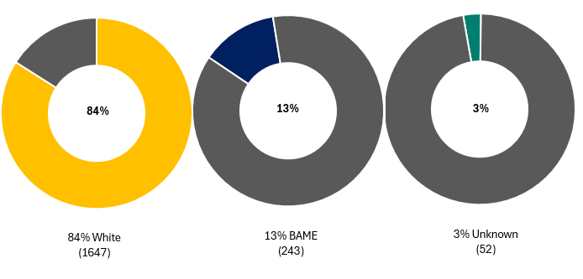

Cardiff Metropolitan Ethnicity Pay Gap 2024

The ethnicity pay gap shows the difference in the average pay between Black, Asian and Minority Ethnic and white staff. An ethnicity pay gap is created, for example, when more white staff are employed in senior roles or a greater number of Black, Asian and Minority Ethnic staff than white staff are employed in lower paid jobs.

Mean Ethnicity Pay Gap
The mean pay gap is the difference between the average hourly earnings of Black, Asian Minority Ethnic staff and white staff.

Table 7: Mean Ethnicity Pay Gap Over Time
 | 31/03/2022 | 31/03/2023 | 31/03/2024
Mean Pay Gap (%) | -3.31 | -1.23 | 2.77

- Our mean ethnicity gap is 2.77% in favour of white staff, which is a shift from having been in favour of BAME staff in 2023.
While the percentage of BAME staff has grown slightly in the upper quartile, it has decreased in both the upper middle and lower middle quartile and increased by slightly under 5% in the lower quartile. The increase in the mean pay gap in favour of White staff is attributable to this growth in the lower quartile.

Median Ethnicity Pay Gap
The ethnicity median pay gap is the difference between the midpoints in the ranges of hourly earnings of Black, Asian and Minority Ethnic staff and white staff.

Table 8: Median Ethnicity Pay Gap Over Time
 | 31/03/2022 | 31/03/2023 | 31/03/2024
Median Pay Gap (%) | -15.85 | -5.5 | -3.01

- Our median ethnicity gap is 3.01% in favour of BAME staff but has been closing year on year.
Due to the increase of 395 in population between 2023 and 2024, there has been growth in headcount across all quartiles.
As shown in figures 6 and 7, the proportion of White staff has increased in both the upper middle (2.99%) and lower middle (1.49%) quartiles, whilst decreasing in both the upper (-1.9%) and lower quartiles (-6.1%). This change in the middle two quartiles has influenced the median negatively.
Between April 2023 and March 2024, we have recruited 230 core staff, 42 BAME and 181 White.
Cardiff Metropolitan University Ethnicity Bonus Gap 2024

The ethnicity bonus gap continues to be 0% as no bonuses are paid.

Ethnicity - Pay by quartile
Figure 6: Headcount by quartile – 2023
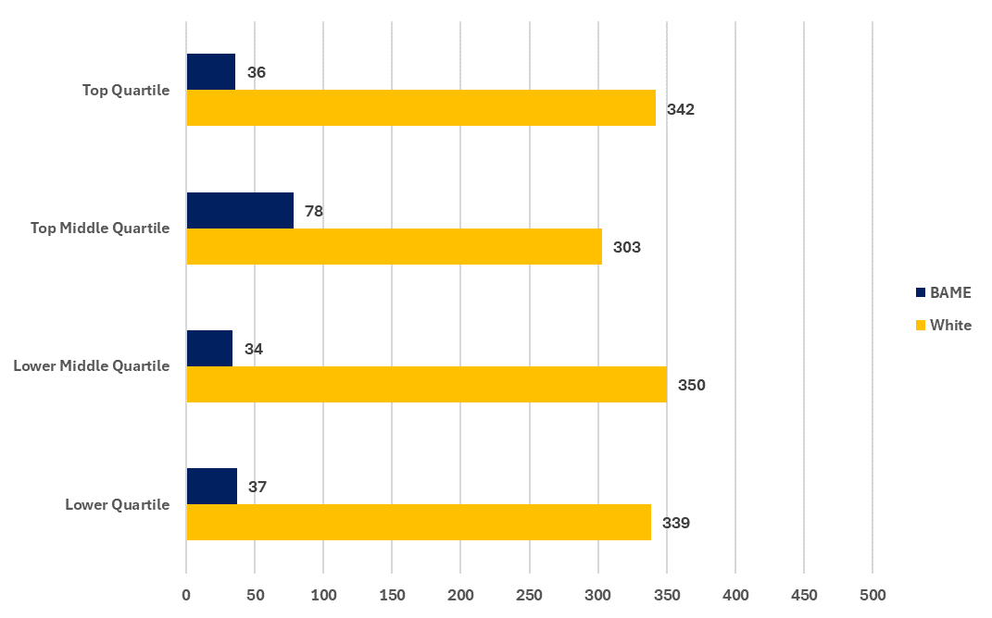
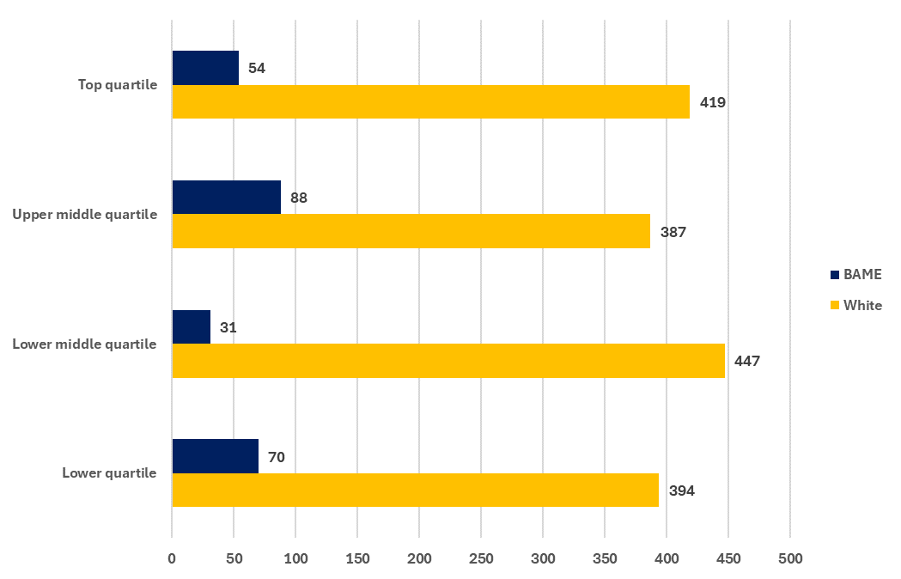
Figure 7: Headcount by quartile – 2024

Disability Pay Gap
We calculate disability pay gap in the same way as we calculate gender pay gap and we use the same data collection point of 31st March 2024. This is the third consecutive year of publishing our findings.

Our disability data may be influenced by a number of staff who have chosen not to voluntarily disclose this information. The University will continue to explore ways of encouraging staff to disclose this information going forward.

For the purposes of reporting our disability pay gap we make comparisons between staff who have declared whether or not they have a disability.

Disability Representation within Cardiff Metropolitan University (March 2024)

The following data below is based on the proportion of staff who declared whether they consider themselves to have a disability (85%).

Figure 8: Headcount by disability declaration – March 2024
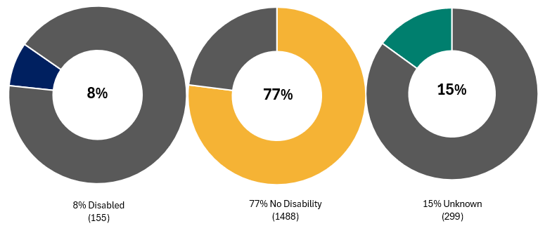

Mean Disability Pay Gap

The mean pay gap is the difference between the average hourly earnings of staff with a declared disability and staff with no known disability.

Table 9: Mean Disability Pay Gap Over Time
 | 31/03/2022 | 31/03/2023 | 31/03/2024
Mean Pay Gap (%) | 6.49 | 5.8 | 7.63

- Our mean disability pay gap is 7.63% in favour of those who declared no disability. This has increased by 1.83% since 2023.
Disability - Median Pay Gap

The disability median pay gap is the difference between the midpoints in the ranges of hourly earnings of staff with no known disability and staff with a declared disability.

Table 10: Median Disability Pay Gap Over Time
 | 31/03/2022 | 31/03/2023 | 31/03/2024
Median Pay Gap (%) | 8.43 | 2.82 | 8.34

- Our median disability pay gap is 8.34% in favour of those with no known disability, which has increased by 5.52% since 2023.

Cardiff Metropolitan University Disability bonus gap 2024

The disability bonus gap continues to be 0% as no bonuses are paid.

Pay by Quartile

The table below shows the hourly pay by quartile for the University based on staff with a disability and with no known disability. It shows that there is a higher proportion of staff with no known disability in all quartiles. There is a higher proportion of staff with a declared disability in the lower quartiles than in the top/upper middle quartiles.

Table 10: Hourly Pay Quarter by Disability
Percentage of staff with a disability and with no disability in each hourly pay quarter | 31/03/2022 | 31/03/2023 | 31/03/2024
Percentage with a declared disability in Top Quartile | 5.49 | 5.68 | 7.21
Percentage with no known disability Top Quartile | 87.80 | 87.08 | 84.94
Percentage with a declared disability in Upper Middle Quartile | 3.94 | 5.43 | 7.62
Percentage with no known disability in Upper Middle Quartile | 86.06 | 83.72 | 82.47
Percentage with a declared disability in Lower Middle Quartile | 6.10 | 6.99 | 8.64
Percentage with no known disability in Lower Middle Quartile | 86.28 | 83.68 | 82.92
Percentage with a declared disability in Lower Quartile | 6.69 | 6.46 | 8.43
Percentage with no known disability in Lower Quartile | 82.37 | 78.04 | 56.17

Intersectionality Data
The University is also presenting intersectional pay gap analysis by gender and ethnicity and also gender and disability. This data is published with the recognition that we continue to face challenges and need to go further in our analysis and understanding of how to address these gaps.

Figure 9: Gender By Disability and Average Hourly Rate (Mean)

Males have a higher average hourly rate of pay in comparison to their female counterparts in all categories.

Figure 10: Gender By Ethnicity and Average Hourly Rate (Mean)

Males have a higher average hourly rate of pay than females across all ethnicity groups.

Our journey to becoming a more inclusive employer

Strategic Equality Plan 2024-28
Our ambitions as set out in the Strategic Equality Plan 2024-28 are to make Cardiff Met a place where all members of our community feel welcome and included to achieve their potential. As well as challenging and holding the University accountable, the Strategic Equality Plan will seek to identify synergy with our Strategy 2030 alongside its enabling and thematic strategies and their KPIs as well as local, regional and UK-wide EDI priorities. The plan has been built around the central theme of belonging that will help us achieve our aspirations. We will strive for a university which reflects our community, champions fair decision-making and promotes innovation. A place where people feel they belong and where they can achieve their full potential.
The implementation of the plan will support the University’s progress to becoming a more inclusive employer, taking positive steps to address inequalities across the organisation.
Five overarching objectives have been identified:
Objective 1 | Take a people-centred approach, understanding the needs of our diverse community and placing this at the forefront of the design and delivery of university functions.
Objective 2 | Promote and embed Equality, Diversity and Inclusion within University decision making.
Objective 3 | Promotion and development of a safe, supportive and fair environment.
Objective 4 | Lead the way as an inclusive and diverse Higher Education Institution and employer.
Objective 5 | Engaging our community
To support our work in addressing the pay gaps identified within this report and our wider inclusion work we have identified 3 priority areas for activity.
- Providing a flexible and inclusive working environment for all
- Inclusive People policies, including generous annual leave, special leave and shared parental leave provisions.
- Being an accredited Real Living Wage employer.
- Continuing to support our active community of employee diversity networks, including having representatives from a variety of staff networks on the University’s Policy Review Group.
- Continuing the roll out of positive behavioural learning interventions across the organisation, including embedding inclusion and diversity content into our Manage@Met Leadership development programme. These are enhanced and updated every year.
- Manage@Met is our mandatory programme for any staff member in Cardiff Met that line manages another staff member. This programme was launched in May 2021 and has fourteen elements that include: Valuing Equality and Diversity - This focuses on inclusivity for all minority groups and also covers overcoming barriers for staff with a disability and support that may be needed. Leading Hybrid Teams - This covers the importance of equal access to information and development and 1-2-1s to ensure any role that is hybrid has no unintended consequences due to for example child/dependency care or domestic violence. Recruitment and Selection Training - This covers unconscious bias and importance of diverse recruitment panels.

- Inclusive recruitment processes
- Ensuring all recruitment panels are diverse and contain members of more than one gender.
- Taking positive action and encouraging applicants from diverse and underrepresented groups to apply for positions.
- Introduction of positive action statements, encouraging applicants from underrepresented backgrounds in Higher Education.

- Nurturing career development
- Our Women to Reader and Professor scheme provides targeted career support for female academic staff to move into reader and chair levels. The scheme has grown considerably from 24 attendees at the inaugural event in 2019 to 97 members in August 2024. In total, 27 of the group have so far been promoted, with 75% of internally promoted women Professors and 86% of internally promoted women Readers coming from within the scheme. As a result, the percentage of women in our Professoriate has risen from 18% when the group was founded to 35%, while the Professoriate’s promotion pipeline of Readers has increased from 50% women to 68%. The members who have been supported by the scheme towards successful promotion now ‘feed forward’ by leading many of the workshops and seminars scheduled throughout the year. Following our successful Athena Swan Silver award, more focus will be placed on the intersection between ethnicity and gender and progression through the academic career pipeline.
- Establishment of the Women Professors Network. The network will provide a confidential space to discuss challenges and an opportunity to engage in active diversification to support women and those from ethnic minorities to Professorship.
- Launch of the Advance HE Diversifying Senior Leadership programme for ethnic minority staff (grade 6 and above) in collaboration with Cardiff University and University Wales Trinity St David’s. 10 members of staff from Cardiff Met attended the programme.
- For all our development call outs for 23/24 we have asked senior leaders to consider and encourage applications from ethnic minority staff members.
- We have continued to include inclusive leadership into our modular leadership programmes for 23/24.
- Our Leaders’ Exchange in May 2023 focussed on Enhancing our Culture; exploring inclusion with a focus on race. In February 2024 our Leaders’ Exchange event socialised our Resolution Framework approach to raise awareness of our move an approach that is a conscious step away from a ‘conflict culture’ and to allow professional disagreement and debate to form part of an innovative and inclusive culture
- Diversifying membership of our Research Degrees Committee, engaging representatives from relevant staff networks and providing opportunities to engage in a university committee.
- Implementation of Union Black Training developed by the Open University supporting the development of an anti-racist culture at Cardiff Met.
- Implementation of BITC-facilitated sessions on 'Leading Conversations about Race' aimed at empowering managers to be more confident in this area, supporting them to engage in difficult conversations but also realise the challenges faced by BAME staff and better support them in their careers.
- Continued implementation of internal leadership programmes (Level 5 and 7 qualifications in leadership and management):
  - Strategic Leader
  - Leader of Others
  - Leader of Self
- Our Performance & Development Review (P&DR) approach launched in April 2020 includes both personal development plans and career development conversations. From March 2024 we have added new guidance asking reviewers to be consciously curious to find out about reviewees’ lived experiences, the impact of these and any additional support they may need.
- Continued support for staff attending external leadership & management development events such as SWIMM and Aurora.
- Our university-wide mentoring network.
- As part of our P&DR annual quality sampling in April 2023 we included specific focus groups for ethnic minority staff. The aim is to better understand their experiences of our P&DR processes and we fed back emerging themes to all senior teams across our schools and professional services directorates.
Data included in this Report
- Salary and workforce information for all staff paid via our payroll as of 31 March 2024.
- The calculations follow current legislative requirements, and we confirm the data reported is accurate.

